**TALBOTT VALUATION ADVISORY SERVICES**

|  |  |
| --- | --- |
| **PREPARED BY:**  **TALBOTT VALUATION ADVISORY SERVICES**  312 CROSSTOWN ROAD  SUITE 256  PEACHTREE CITY, GEORGIA 30269 | **appraisal report**  **INDUSTRIAL CONDOMINIUM**  4735 DWIGHT EVANS ROAD  CHARLOTTE, NORTH CAROLINA 28217  FILE NO. 22061  **EFFECTIVE DATE:**  JULY 5, 2022  **PREPARED FOR:**  MR. HERB McKOY  PACIFIC WESTERN BANK  5404 WISCONSIN AVENUE, 2nd Floor  CHEVY CHASE, MARYLAND 20815  AND  U.S. SMALL BUSINESS ADMINISTRATION  **LOAN NAME: GDS FOOTWEAR**  **CLIENT REFERENCE: 21665** |
|  |  |

312 CROSSTOWN ROAD

SUITE 256

PEACHTREE CITY, GEORGIA 30269

July 6, 2022

Mr. Herb McKoy

Pacific Western Bank

5404 Wisconsin Avenue, 2nd Floor

Chevy Chase, Maryland 20815

and

U.S. Small Business Administration

Re: Industrial Condominium

4735 Dwight Evans Road

Charlotte, North Carolina 28217

*Loan Name: GDS Footwear*

*Client Reference: 21665*

TVAS File Number: 22061

Dear Mr. McKoy:

In accordance with your request, we have completed an appraisal of the above-referenced property. The purpose of the appraisal is to develop an opinion of the market value of the fee simple interest in the subject property, subject to certain definitions, assumptions and limiting conditions as set forth in the accompanying report.

The subject property was inspected on July 5, 2022, the effective date of this report. The client for this assignment is identified as Pacific Western Bank. The intended users of this report are Pacific Western Bank and the U.S. Small Business Administration, and the intended use is for loan underwriting and/or credit decisions.

The appraisal is intended to conform with the Uniform Standards of Professional Appraisal Practice (USPAP), the Code of Professional Ethics and Standards of Professional Appraisal Practice of the Appraisal Institute, applicable state appraisal regulations, and the appraisal guidelines of our client. The appraisal is also prepared in accordance with the appraisal regulations issued in connection with the Financial Institutions Reform, Recovery and Enforcement Act (FIRREA).

The following appraisal presents the most relevant data gathered in our investigation, details of the processes utilized, and the interpretation and reconciliation of our analysis leading to the opinion of value.

Mr. McKoy **TVAS**

Pacific Western Bank

July 6, 2022

Page 2

The subject property consists of a 16,268-square-foot industrial warehouse condominium and an undivided interest in the common elements of D’Evans Project Condominium situated on the southeast side of Dwight Evans Road within the city limits of Charlotte in Mecklenburg County, North Carolina.

D’Evans Project Condominium is an industrial complex consisting of four general purpose warehouse buildings situated on a 2.59-acre lot. The subject building, designated as Unit 4, was constructed in 1989. The building is currently vacant and formerly tenant-occupied by a car wash chemical company.

Based on the examination and analysis, it is our opinion that the market value of the fee simple interest in the subject property, subject to certain definitions, assumptions and limiting conditions as set forth in the accompanying report, as of July 5, 2022, was:

|  |
| --- |
| **ONE MILLION NINE HUNDRED FIFTY THOUSAND DOLLARS** |
| **$1,950,000** |

If you have any questions or comments, please contact the undersigned. Thank you for the opportunity to be of service.

Respectfully Submitted,



J. Carl Talbott, III

Certified General Real Estate Appraiser

North Carolina Temporary License No. 10729

Telephone: (470) 648-6965

Email: [carl@talbottvas.com](mailto:carl@talbottvas.com)

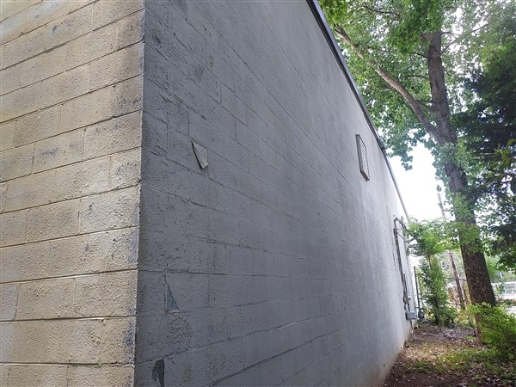

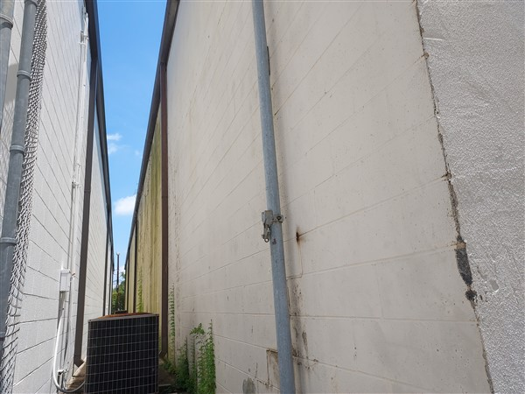

~@10

Northeastern (Rear) Elevation of the Subject Building

# Table of Contents

EXECUTIVE SUMMARY 1

Property Identification 1

Property History 1

Site Characteristics 1

Improvements 2

Highest and Best Use 2

Valuation 3

Conditions of the Assignment 3

Pro Forma Data 3

Value Conclusions 4

SCOPE OF WORK 4

Report Criteria 4

Property History 5

Data Sources 5

Valuation Approaches 6

Definition of Values 6

Exposure/Marketing Time 6

Competency Statement 8

AREA ANALYSIS 9

Summary of Economic Activity 10

North Carolina Economy 13

NEIGHBORHOOD ANALYSIS 18

Overview 18

Access and Linkages 19

Population 19

Households 20

Housing 20

Income 21

Employment 21

Conclusion 23

MARKET ANALYIS 24

Charlotte Industrial Market 24

Leasing Activity 25

Rental Rates 26

Construction Activity 27

Sales Activity 29

Tyvola Road Industrial Submarket 32

Submarket Leasing Activity 33

Submarket Rental Rates 33

Submarket Construction Activity 34

Submarket Sales Activity 34

SITE DESCRIPTION 37

Physical Characteristics 37

Utilities 38

Legal Information 38

Surrounding Arterials 39

Flood Zone Map 39

Parcel Map 40

IMPROVEMENTS DESCRIPTION 41

General Description 41

Construction Details 42

Interior Elements 42

Mechanical Systems 42

Special Improvements 43

Quality and Condition 43

Building Sketch 44

ZONING 45

Zoning Summary 45

Development Standards 45

Zoning Map 46

REAL ESTATE TAXES AND ASSESSMENT 47

Introduction 47

Current Property Tax Liability 47

HIGHEST AND BEST USE 48

Introduction 48

Highest and Best Use as Vacant 48

Highest and Best Use as Improved 49

Most Probable Buyer 49

VALUATION PROCESS 50

Methodology 50

Cost Approach 50

Sales Comparison Approach 50

Income Capitalization Approach 50

Summary 51

SALES COMPARISON APPROACH 52

Summary of Comparable Improved Sales Data 52

Comparable Improved Sales Map 56

Comparable Improved Sales Adjustment Grid 57

Comparable Improved Sales Analysis 58

Value Conclusion 61

INCOME CAPITALIZATION APPROACH 63

Summary of Comparable Rental Data 63

Comparable Rentals Map 66

Comparable Rentals Adjustment Grid 67

Comparable Rentals Analysis 68

Market Rent Conclusion 70

Potential Gross Income 70

Analysis of Expenses 71

Mortgage-Equity Capitalization 73

Debt Service Coverage Ratio Technique 74

Charlotte Market Sales History 74

Capitalization Rate Conclusion 75

Value Conclusion 75

RECONCILIATION AND FINAL VALUE CONCLUSIONS 76

Summary of Value Indications 76

Market Value Conclusion 76

CERTIFICATION 77

ADDENDA 78

Assumptions and Limiting Conditions 78

Qualifications of the Appraiser 80

Comparable Sales Data 81

Comparable Rental Data 86

Engagement Letter 90

Insurable Value 91

Terms and Definitions 92

# EXECUTIVE SUMMARY

~@11

|  |  |
| --- | --- |
| Templateprop | Propdata |
|  |  |

Property Historiiie

|  |  |
| --- | --- |
| Current Owner(s) | Investcore Prop Co 9, LLC |
|  |  |
| Previous Market Sale | November 18, 2020 |
|  |  |
| Previous Sale Price | $1,360,000 |
|  |  |
| Other Sales – Past Three Years | None noted |
|  |  |
| Property Status | Pending Sale |

Site Characteristics

|  |  |  |
| --- | --- | --- |
| Condominium Site Gross Area | 2.59 Acres | 112,820 SF |
|  |  | |
| Site Shape | Irregular | |
|  |  | |
| Topography | Gently Sloping | |
|  |  | |
| Soils | Appear adequate to support existing improvements | |
|  |  | |
| Current Zoning | I-2, Heavy Industrial District  City of Charlotte | |
|  |  | |
| Utilities | All Available | |
|  |  | |
| Easements/Encroachments | Typical Easements | |
| Street(s) | Access | Exposure |
| Dwight Evans Road | Direct | Average |

Improvements

|  |  |
| --- | --- |
| Construction | Class S, Structural Steel-Frame |
|  |  |
| Gross Building Area (SF) | 16,268 |
|  |  |
| Rentable Building Area (SF) | 16,268 |
|  |  |
| Mezzanine (SF) | None |
|  |  |
| Year Built | 1989 |
|  |  |
| Tenancy | Single |
|  |  |
| Occupancy | Vacant |
|  |  |
| Grade-Level Loading | None |
|  |  |
| Dock-High Loading | Three |
|  |  |
| Eave Height | 18 feet |
|  |  |
| Finished Ratio | 7.4% |
|  |  |
| Condominium Site Coverage Ratio | 51.2% |
|  |  |
| Parking Ratio | 0.92/1,000 SF |
|  |  |
| Effective Age | 10 years |
|  |  |
| Remaining Economic Life | 30 years |

Highest and Best Use

|  |  |
| --- | --- |
| Highest and Best Use as Vacant | Commercial Use |
|  |  |
| Highest and Best Use as Improved | Continued Use of Existing Improvements |

Valuation

|  |  |
| --- | --- |
| Value Type | Market Value “As-Is”  Insurable Value |
|  |  |
| Property Rights Appraised | Fee Simple |
|  |  |
| Exposure Time | 6 – 9 months |
|  |  |
| Marketing Time | Up to one year |

Conditions of the Assignment

|  |  |
| --- | --- |
| Extraordinary Assumptions | None |
|  |  |
| Hypothetical Conditions | None |
|  |  |
| Assumptions and Limiting Conditions | See Addenda |

Pro Forma Data

|  |  |  |  |  |
| --- | --- | --- | --- | --- |
| Income Pro Forma | | | | |
| Revenue |  |  |  |  |
| Base Rent |  |  |  | $146,412 |
| Other Income |  |  |  | $0 |
| Reimbursements |  |  |  | $0 |
| Potential Gross Income |  |  |  | $146,412 |
| Vacancy and Collection Loss | 4.0% |  |  | ($5,856) |
| Effective Gross Income |  |  |  | $140,556 |
| Expenses |  |  |  |  |
| Property Management | 2.0% | $2,811 |  |  |
| Reserves | 2.0% | $2,811 |  |  |
| Total Expenses |  |  |  | ($5,622) |
| Net Operating Income |  |  |  | $134,933 |

Value Conclusions

|  |  |  |
| --- | --- | --- |
| Market Value “As-Is” | | |
|  | Effective Date of Value | Indicated Value |
|  |  |  |
| Sales Comparison Approach | July 5, 2022 | $1,950,000 |
|  |  |  |
| Income Capitalization Approach | July 5, 2022 | $1,930,000 |
|  |  |  |
| Market Value Conclusion | July 5, 2022 | $1,950,000 |

# SCOPE OF WORK

Report Criteria

|  |  |
| --- | --- |
| Report Format | Appraisal Report |
|  |  |
| Purpose of the Appraisal | Estimate Market Value as defined by the Board of  Governors of the Federal Reserve System, in accordance with Title XI of FIRREA (1989) |
|  |  |
| Intended Use | To aid in loan underwriting in connection with the acquisition, disposition and/or refinancing of the subject property |
|  |  |
| Client | Pacific Western Bank |
|  |  |
| Intended User(s) | The Intended Users are Pacific Western Bank and the US Small Business Administration. Pacific Western Bank and its respective affiliates (collectively **"PacWest"**) together with its successors, assigns and transferees with respect to its interests in the subject financing and/or any party to whom PacWest has pledged its interest in the subject financing may use and rely upon this Report in connection with the making of a mortgage loan. Further, PacWest may furnish this report to third parties involved in evaluating or auditing the subject financing, provided that no such parties may use or rely upon any such information unless the same have succeeded to PacWest's interest in connection therewith. Finally, in compliance with banking regulations and internal policy, PacWest may provide a copy of this Report to prospective borrowers on a non- reliance basis for informational purposes only. |
|  |  |
| Property Rights Appraised | Fee Simple |
|  |  |
| Date of Report | July 6, 2022 |
|  |  |
| Date of Inspection | July 5, 2022 |
|  |  |
| Date(s) of Value | July 5, 2022 |
|  |  |
| Property Contact - Name | Grant Stevens |
|  |  |
| Property Contact – Phone | (980) 428-2222 |
|  |  |
| Inspection Details | The appraiser was provided access to all interior areas within the subject’s improvements. |

Property History

According to tax records, the subject property is currently owned by Investcore Prop Co 9, LLC.

On November 18, 2020, Investcore Prop Co 9, LLC purchased the subject property from Park Avenue Partners, LLC for a reported $1,360,000. The property was formerly tenant-occupied by a car wash chemical company dba Top Line Chemicals who vacated the property in December 2020.

Subsequent to the tenant vacating, the subject property was listed for lease by KW Commercial with an original asking rental rate of $10.50 per square foot per year and reduced to $9.50. After failing to secure a new tenant, the property was listed for sale in November 2021 with an asking price of $2,100,000.

On February 23, 2022, a Purchase and Sale Agreement was executed and accepted between the seller and buyer, GDS Footwear, Incorporated for $1,950,000. Upon closing of the pending transaction, the subject property will be 100 percent owner-occupied.

We found no evidence of any other title transfers during the three years prior to the date of this report. We are not aware of any other agreements for sale, option, or listing currently in existence concerning the subject property.

Data Sources

|  |  |
| --- | --- |
| Site To Do Business (STDB) | Costar |
|  |  |
| LoopNet | U.S. Bureau of Labor Statistics |
|  |  |
| Government Officials | North Carolina Department of Labor |
|  |  |
| Reonomy | Institute of Real Estate Management |
|  |  |
| Marshall Valuation Services | Local brokers |
|  |  |
| Realty Rates | CompStak |

Valuation Approaches

|  |  |
| --- | --- |
| Approaches Utilized | Approaches Omitted |
|  |  |
| Sales Comparison | *Cost Approach |
|  |  |
| Income Capitalization Approach |  |

* The *Cost Approach* was excluded from this appraisal because of the age of the improvements and the inherent difficulty in accurately quantifying depreciation for this type of asset.

Definition of Values

**Market value** is defined as: *the most probable price that a property would bring in a competitive and open market under all conditions requisite to a fair sale, the buyer and seller each acting prudently and knowledgeably, and assuming the price is not affected by undue stimulus. Implicit in this definition is the consummation of a sale as of a specified date and the passing of title from seller to buyer under conditions whereby:*

* *Buyer and seller are typically motivated;*
* *Both parties are well informed or well advised, and acting in what they consider to be their own best interests;*
* *A reasonable time is allowed for exposure in the open market;*
* *Payment is made in terms of cash in U.S. dollars or in terms of financial arrangements comparable thereto; and*
* *The price represents the normal consideration for the property sold unaffected by special or creative financing or sales concessions granted by anyone associated with the sale.[1]*

**Insurable Value** is defined as: *the value used by insurance companies as the basis for insurance. Often considered to be replacement or reproduction cost plus allowances for debris removal or demolition less deterioration and non-insurable items. Sometimes cash value or market value, but often entirely a cost concept.[2]*

Exposure/Marketing Time

Exposure time is the estimated time a property would have been offered to the market at a price equivalent to market value *prior* to sale on the effective date of valuation. Marketing time is the period of time necessary to sell the subject property interest at its estimated market value *after* the effective date of valuation.

Marketing periods for transactions involving comparable properties can provide a reasonable proxy for determining an appropriate exposure time for the subject. We reviewed sales of similar properties to determine an appropriate exposure time for the subject property. The indicated months-to-sale for comparable properties is between six and nine months.

Financial and real estate markets are in a state of uncertainty associated with the novel corona virus/COVID-19. The outbreak of COVID-19 is a rapidly evolving situation and the effects on real estate markets are currently unclear. As such, it is difficult to predict with any certainty the consequences on either a near-term or long-term basis.

Given the nature of these recent economic events which have created unprecedented volatility in markets, a forward-looking analysis and understanding of market conditions is considered necessary. The pandemic has exacerbated the ill effects of an economy which had been exhibiting signs of weakness for several quarters. The short-term outlook remains somewhat negative as the economy had entered into a recession with record-level changes in existing employment. Since the beginning of the outbreak a significant portion of these losses have been recovered but unemployment figures remain above the historical average. The medium and long-term outlooks are certainly much more favorable yet remain questionable.

The intensity and duration of repercussions experienced by the pandemic will obviously differ based on location and property type. There is considerable uncertainty surrounding real estate and the presumptions regarding future business practices.

The projected job growth in the subject’s market is beginning to show signs of normalization similar to historical growth prior to the onset of the pandemic. However, with the continued development and spread of variants and the general unpredictability of the virus, along with the current economic strategies implemented by the Federal Reserve, it is our opinion that forecasted market conditions will differ slightly from market conditions experienced within the last year. Based on our analysis, we conclude the subject property to have an exposure time of six to nine months and a marketing time of up to one year.

Competency Statement

The Competency Provision of the Uniform Standards of Professional Appraisal Practice, promulgated by the Appraisal Foundation and required as part of the Financial Institutions Reform, Recovery, and Enforcement Act, states that:

*Prior to entering an agreement to perform any assignment, an appraiser must properly identify the property to be appraised and have the knowledge and experience that will be required to complete the assignment competently or alternatively:*

*Disclose the lack of knowledge and/or experience to the client before accepting the assignment;*

*Take all appropriate steps necessary to complete the assignment competently; and*

*Describe the lack of knowledge and/or experience and the steps taken to complete the assignment competently in the report.*

The appraisers affirm that they have the knowledge and experience to competently complete the assignment in accordance with the competency provision in USPAP.

# AREA ANALYSIS

The subject property is located within the city limits of Charlotte in Mecklenburg County approximately four miles southwest of the city’s central business district. The center of the metropolitan area is the city of Charlotte and includes the cities of Gastonia, Concord, Huntersville, and Rock Hill as well as the large suburban area in the counties surrounding Mecklenburg County. Located in the Piedmont, it is the largest metropolitan area in the Carolinas, and the fourth largest in the Southeastern United States. The Charlotte metropolitan area is one of the fastest growing metropolitan areas in the United States.

Area Map

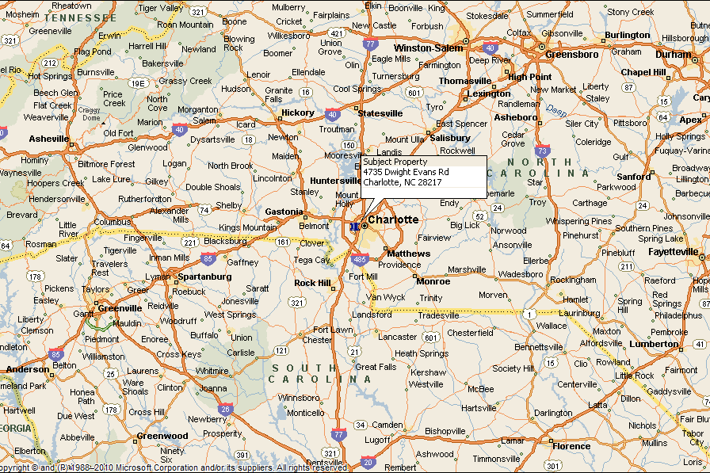

The Federal Reserve Bank of Richmond[3] provides the following commentary on current economic conditions in the Fifth District as of June 2022.

Summary of Economic Activity

*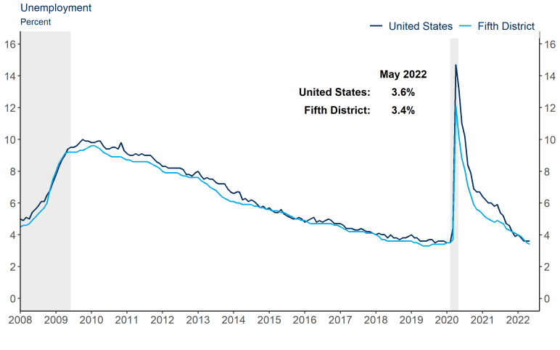The regional economy grew at a modest rate. Manufacturing activity increased at a modest to moderate rate as producers continued to face challenges meeting demand due to supply chain disruptions and labor shortages. Fifth District ports reported an increase in loaded exports but a slight decline in imports, although import volumes remained historically high. Similarly, trucking demand eased slightly but remained strong relative to prior years. Retail sales remained strong while new vehicle sales remained low due to low inventory levels. Leisure travel held strong with some increases noted for group travel, weddings, and small events. Residential real estate activity slowed modestly, and some potential buyers were getting priced out of the market as interest rates and home prices rose. Meanwhile, commercial real estate activity remained strong, particularly for Class A office and industrial space. Financial institutions reported a slight slowdown in lending across most loan types, one exception being used vehicle lending, which continued to grow. Nonfinancial service firms saw moderate growth in sales but expressed some concerns that inflation could hamper growth in coming months if it remains elevated. Employment increased modestly and wage growth remained moderate, overall, as many employers continued to cite challenges finding and retaining workers. Price growth remained robust in recent weeks.*

***Labor Markets***

*Employment in the Fifth District increased modestly amid ongoing reports of worker shortages and high turnover. A majority of contacts continued to cite difficulties finding and retaining workers across all skill levels. Among the small number of contacts reporting improving worker availability, most said that improvements came after raising wages. Additionally, one contact said that they recently made a change to their payroll policy that allowed hourly, part-time employees to be paid in a much shorter amount of time and that helped increase interest in those positions. Overall, wages increased at a moderate rate, with some reports of larger increases for highly specialized positions and for those in very short supply.*

***Prices***

*Overall, price growth remained significantly elevated in recent weeks. According to our surveys, service sector firms reported that price growth picked up from an already robust rate. Manufacturers, on the other hand, reported a slight moderation in price growth, but compared to last year, prices were still growing at a strong rate. Firms in both manufacturing and nonmanufacturing sectors continued to cite material shortages and rising fuel costs as contributors to price escalation. Labor costs also contributed to price growth as many firms continue to increase wages and benefits to recruit and retain workers.*

***Manufacturing***

*Fifth District manufacturers reported a moderate increase in shipments and a modest increase in new orders. Several contacts noted that supply chain issues and worker shortages limited their productive capacity and added to their backlogs. In response to labor challenges and continued strong demand, some companies looked to invest in automation and technology to increase production and reduce dependence on labor. A few manufacturers, however, said that demand softened slightly, which was attributed to inflation and consumers shifting spending away from durable goods.*

***Ports and Transportation***

*Overall, ports experienced continued strong container volumes, with solid growth in loaded containers and empties for export. Meanwhile, import volumes declined slightly, which relieved some of the congestion at the ports. Spot shipping rates continued to decline slightly but remained well above 2019 levels. Fifth District ports were watching for a potential summer surge in imports caused by Asian ports reopening after COVID disruptions and carriers potentially diverting ships to East Coast ahead of the West Coast longshoreman union negotiations in July. Air freight volume declined slightly while air freight rates increased this period.*

*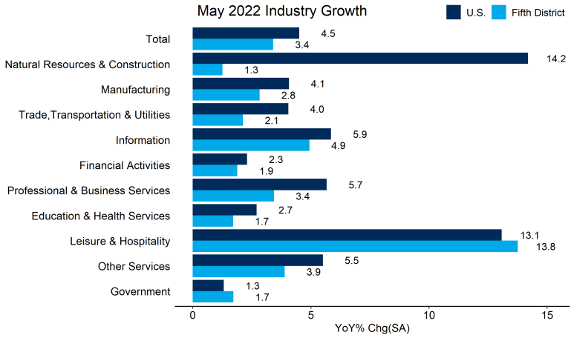Trucking companies reported that demand remained strong, but that the number of booked orders decreased despite businesses' inventory levels still being low. Capacity loosened slightly, through still tight, and spot rates declined this period; however, fuel surcharges offset much of the cost savings. Most trucking companies noted improvement in their ability to hire new drivers. Trucking firms were receiving deliveries of the new equipment they ordered in 2021, though they still had to rely on older equipment to meet demand.*

***Retail, Travel, and Tourism***

*Retail sales remained strong with most stores able to pass on increased costs to consumers. However, labor availability continued to be a headwind for most retailers with wages increasing in order to attract and retain workers. Rising inventory and materials costs were an issue in terms of future pricing as well. With automotive manufacturers unable to maintain production due to supply chain issues, automobile dealers stated that their inventory of new cars continued to be extremely low, negatively impacting their sales revenue.*

*In the Fifth District, leisure travel remained strong, and contacts reported that group travel had started to come back. More weddings and smaller events occurred, but conventions have not fully returned yet. Both hotel occupancy rates and average daily rates were increased in recent weeks. Passenger counts at airports had almost fully recovered to their pre-pandemic levels despite ticket prices being far higher than in 2019. Overall, the hospitality sector continued to experience strong demand, but were still grappling with staffing shortages despite increased wages and benefits.*

***Real Estate and Construction***

*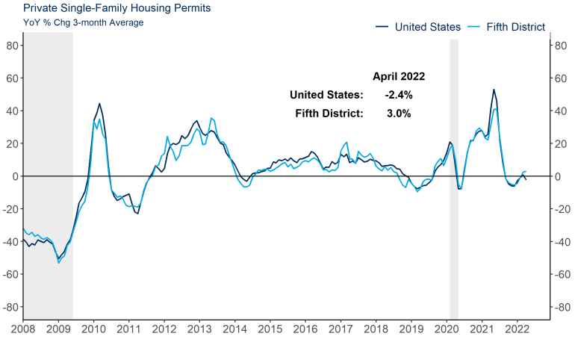Sales and buyer traffic decreased this period compared to the first quarter of 2022 as housing inventory levels remained constrained and home prices continued to rise. Since our last report, some potential homebuyers were starting to be priced out of the market by higher interest rates combined with elevated home prices. Residential construction costs for both materials and labor continued to rise, but availability of construction materials improved. Real estate agents noted that it still was very competitive market for buyers.*

*Overall, commercial real estate activity remained strong this reporting period. Class A office leasing activity was robust, especially in suburban markets. Supplies of existing buildings in most commercial real estate categories were tight. Availability of industrial properties continued to be constrained due to demand outpacing supply, despite slowing absorption rates and rising rental rates. Commercial property sales were strong with lots of investment money reportedly chasing too few deals. New commercial construction was hampered by escalating costs and availability of materials, as well as shortages of skilled labor.*

***Banking and Finance***

*There continued to be strong loan demand across most commercial loan types, but there are signs of a slowing due to rising rates. Residential mortgage demand continued to slow, which was observed as a byproduct of increasing rates and rising home prices. New auto lending was still being impacted from inventory shortages, however, used auto lending demand continuing to increase. Deposits continue to trend upward, but at a slowing pace. Commercial credit quality remained good, and delinquencies remain low. Some institutions noted that consumer loan quality is beginning to weaken, and delinquencies are starting to increase slightly, especially from borrowers with limited discretionary income.*

***Nonfinancial Services***

*Nonfinancial service providers continued to report moderate growth in revenues and solid demand in recent weeks. Although many firms were experiencing positive growth, there was widespread concern that inflation could hamper growth in the near-term. One professional service firm said that their plans for hiring, and capital spending were put on hold because they saw their clients capping or cutting budgets out of caution. Additionally, a consultant was concerned that they might lose one of their major clients because that client was facing a contract renewal for electricity and might need to cut spending to offset increased costs of energy.*

North Carolina Economy

*Economic data in North Carolina were mostly positive in recent weeks. Employment rose and the unemployment rate fell. Meanwhile, home price appreciation remained very strong.[4]*

*Labor Markets*

*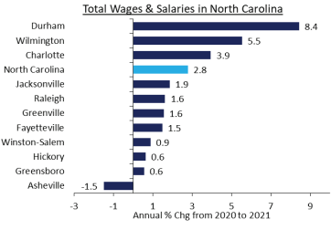• Total payroll employment in North Carolina increased by 11,300 jobs (0.2 percent), on net, in April. The most jobs were added over the month in professional and business services (5,500 jobs). Meanwhile, the most jobs were lost in construction (5,900 jobs).*

*• On a year-over-year basis, payroll employment in North Carolina was up by 185,600 jobs (4.1 percent), on net. Employment was 2.4 percent higher than in February 2020. Jobs were added over the year in all industries, except natural resources, logging, and mining and construction which lost 200 jobs each. The most jobs were added in leisure and hospitality (52,400 jobs).*

*• The unemployment rate in North Carolina fell 0.1 percentage point to 3.4 percent in April. It was 1.7 percentage points below its reading in April 2021 and 0.3 percentage points below its pre-pandemic level in February 2020.*

*Housing Markets*

*• Residential permitting activity was up 11.3 percent in North Carolina from March to April, and new permit levels were 12.4 percent above their April 2021 levels.*

*• According to CoreLogic Information Solutions, home values in North Carolina appreciated 2.8 percent in March and 24.6 percent since March 2021. 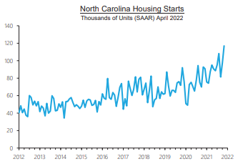*

*Personal Income*

*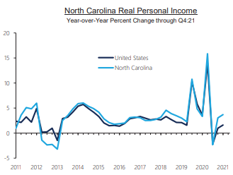Personal Income for Metropolitan Areas is published on an annual basis by the Bureau of Economic Analysis. Statistics for calendar year 2020 were released on November 16, 2021. The data have not been adjusted for inflation.*

*• North Carolina’s per capita personal income in 2020 was $50,996. Among North Carolina MSA’s, Raleigh had the highest per capita personal income at $60,884. The Raleigh MSA had the lowest growth in per capita personal income of 4.2 percent. The Fayetteville MSA had the largest growth in per capita personal income of 7.7 percent.*

CoStar Group[5] provides the following metro area economic summary and forecast as of 2Q 2022.

*Charlotte's* *banking industry bolstered its economy through the most recent economic downturn.*

*Employment in the market was 2.7% above its pre- pandemic peak as of April 2022, while nationwide employment was still down -0.7% since February 2020. Office-using sectors, particularly financial services and professional services have driven the market's recovery. Charlotte has added more than 14,000 office-using jobs. Other sectors that have fully recovered or outpaced national norms include the transportation and warehousing industry and the construction industry.*

*Home to the headquarters or largest employment center of three of the nation's six largest banks — Bank of America, Wells Fargo, and Truist — the relative strength of the financial activities industry stabilized job losses in other industries, and continued population growth in the region led to an increase in e-commerce and accompanying warehousing jobs.*

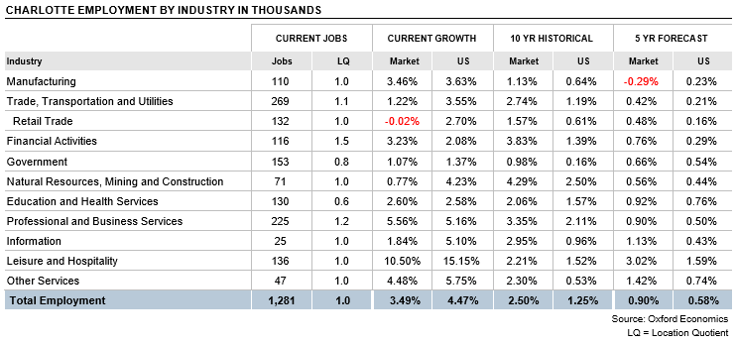

*For manufacturers, supply chain challenges in the auto parts and machinery subsectors and declining demand for apparel and furniture — two legacy subsectors in the region — contributed to manufacturing job loss. In leisure and hospitality, the Charlotte market's reliance on business travel and related hospitality services have kept the recovery in hotel and restaurant jobs more sluggish.*

*Despite the downturn, Charlotte continues to attract headquarters and office relocations. Since 2018, four Fortune 1000 companies — Honeywell, Dentsply Sirona, Truist Financial, and Centene — have officially moved their national or regional headquarters to the market. Most recently, Fortune 42 healthcare conglomerate Centene broke ground on its East Coast headquarters in the University Submarket, planned for 3,200 employees.*

*Nine Fortune 500 and 18 Fortune 1000 companies are now headquartered here. And while the financial services sector is well represented in Bank of America, Truist, and Brighthouse Financial, retailers like Lowe's, manufacturers like Nucor, Sealed Air, Albemarle, and Ingersoll Rand, and major utility Duke Energy also draw on Charlotte's lower costs of living, hub airport access, and a pool of professional services talent as their headquarters market.*

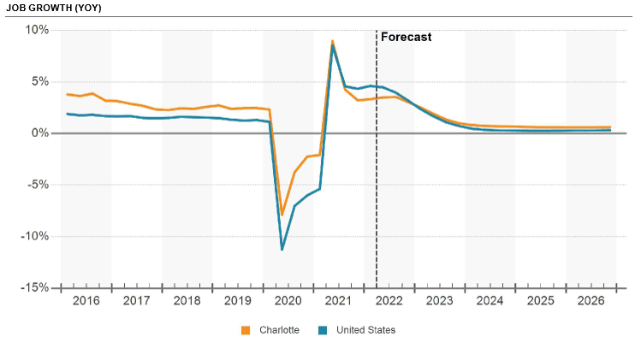

*As technology needs grow across all industries, companies like Honeywell, Lowe's, and Allstate have expanded their tech practices in the market, particularly in Uptown and SouthEnd. Tech talent growth in Charlotte builds off momentum from the digital transformation of* *financial activities. In addition to growing tech workforces at big banks, homegrown payments and FinTech companies like AvidXchange and LendingTree grew from startups to large corporate tenants, paving the way for Silicon Valley firms like Credit Karma, which opened an East Coast office in the Ballantyne Submarket in 2018 and announced a 600-job expansion in May 2021, and Robinhood, which in March 2021 announced it would bring 389 new jobs to Charlotte, in Uptown's Legacy Union II building. Microsoft continues to add to its 1,000- plus headcount in the city's Southwest Submarket, while marketing analytics company Red Ventures employs more than 2,000 on its campus just across the South Carolina border in Lancaster County.*

*While manufacturing employment has struggled, the move to e-commerce has boosted industrial activity, with continued expansions from Amazon in the Airport, Southwest, and Cabarrus County submarkets, as well as announcements from Walmart in Iredell County, Ross Stores, whose distribution center will add 700 jobs in York County, and a 2,000-job ramp up of Macy's new distribution facility in Rowan County. More recently, Rauch, Red Bull, and Ball Metals announced a 750-job expansion in Cabarrus County.*

*British Electric vehicle maker Arrival created buzz with the announcement it would open its North American headquarters and two manufacturing facilities here, adding more than 600 jobs, thanks to a contract to make electric vans for UPS.*

*Charlotte's healthcare and life sciences industry also passed a milestone in March when Atrium Health and Wake Forest University School of Medicine announced official plans for a medical school. The Charlotte market's first four-year medical school will be located on a mixed- use campus near Atrium's flagship hospital in the Midtown Submarket including up to 1.3 million SF of office, multifamily, retail, and hotel space, in addition to educational and research facilities. The first students are scheduled to arrive in fall 2024. Another boost to Charlotte's life sciences and medical device manufacturing sector came in January 2022, when Eli Lilly announced plans to add a facility in Cabarrus County.*

*As a fast-growing Sun Belt region, Charlotte has long been a destination for newcomers from higher-cost regions, particularly in the Northeast and Midwest. Charlotte's population grew by about 20% over the decade of the 2010s, and those newcomers were* *disproportionately white-collar professionals.*

*Rapid population growth has led to a tight housing market, with the regional realtors association reporting less than one month of home inventory on the market as of April 2022. Median home sales prices of around $380,000, up 20.6% year over year, remain low compared to larger markets.*

*The growth has also led local governments to a renewed emphasis on infrastructure and transit planning. The LYNX Blue Line and Extension light rail projects, completed in 2018, sparked transit-oriented development and transformed areas like South End and NoDa into adaptive reuse and entertainment destinations. Leaders are considering an $8 billion-$12 billion expansion plan, including a proposed Silver Line connecting the Charlotte Douglas International Airport with uptown and suburbs Belmont and Matthews, along with bike and pedestrian infrastructure and a bus system overhaul. A referendum to pay for the Strategic Mobility Plan through an additional one-cent sales tax could go in front of Mecklenburg County voters in 2022 but is likely to face opposition from suburban towns north of Charlotte and could face an uphill battle from state lawmakers.*

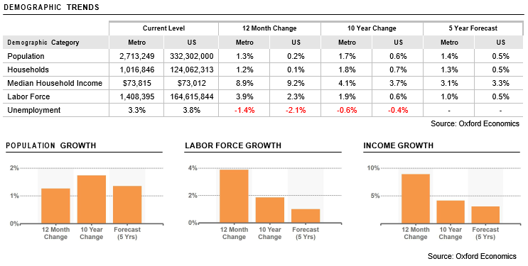

# NEIGHBORHOOD ANALYSIS

A neighborhood is defined as a grouping of complimentary land uses affected by similar operations of the social, economic, governmental, and environmental forces that influence property values. Therefore, it is necessary to evaluate the dynamics of these forces within the defined neighborhood to understand their effect on the projected value of a real estate property. For purposes of our analysis, the subject neighborhood is defined as the area within a ten-minute drive of the subject property.

**Neighborhood Map**

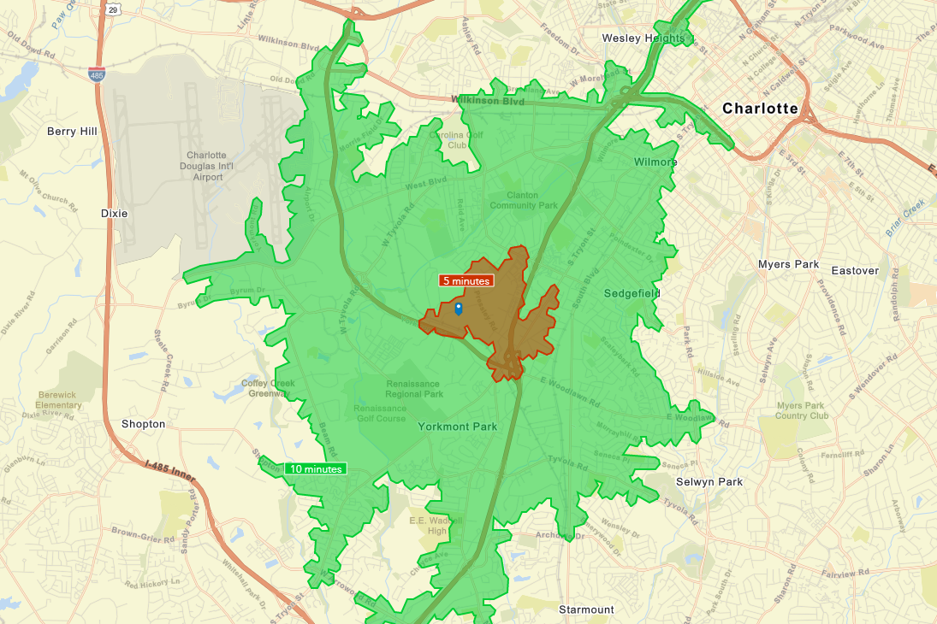

Overview

The area is comprised of commercial and industrial development on the main arterials, with residential and developments located on the secondary roads. The subject property is located on the southeast side of Dwight Evans Road less than one mile northwest of the Interstate 77/Billy Graham Parkway interchange and about two miles southeast of Charlotte Douglas International Airport. The immediate area comprises industrial uses and is adjacent to a major commercial node extending along South Tryon Street from the central business district of Charlotte. There are several major shopping centers located within five miles of the subject.

Access and Linkages

|  |  |
| --- | --- |
| Freeways | Interstate 77 |
|  |  |
| North/South Arterials | Interstate 77  Billy Graham Parkway  South Tryon Street |
|  |  |
| East/West Arterials | Wilkinson Boulevard  Woodlawn Road |
|  |  |
| Comments | The subject’s proximity to transportation routes is considered good. |
|  |  |

Population

|  |  |  |  |
| --- | --- | --- | --- |
|  | *5-Minute Drive* | | *10-Minute Drive* |
| *2010 Population* | | *444* | *39,913* |
| *2020 Population* | | *542* | *50,016* |
| *2022 Population* | | *703* | *53,125* |
| *2027 Population* | | *1,557* | *57,971* |
| *2010-2020 Annual Rate* | | *2.01%* | *2.28%* |
| *2020-2022 Annual Rate* | | *12.25%* | *2.72%* |
| *2022-2027 Annual Rate* | | *17.24%* | *1.76%* |
| *2022 Male Population* | | *46.4%* | *48.5%* |
| *2022 Female Population* | | *53.6%* | *51.5%* |
| *2022 Median Age* | | *39.5* | *33.7* |

*Source: ESRI Business Analyst*

Households

|  |  |  |
| --- | --- | --- |
|  | *5-Minute Drive* | *10-Minute Drive* |
| *2010 Households* | *166* | *17,256* |
| *2020 Households* | *206* | *23,968* |
| *2022 Households* | *279* | *26,225* |
| *2027 Households* | *646* | *28,750* |
| *2010-2020 Annual Rate* | *2.18%* | *3.34%* |
| *2020-2022 Annual Rate* | *14.43%* | *4.08%* |
| *2022-2027 Annual Rate* | *18.28%* | *1.86%* |
| *2022 Average Household Size* | *2.49* | *2.02* |

*Source: ESRI Business Analyst*

Housing

|  |  |  |
| --- | --- | --- |
|  | *5-Minute Drive* | *10-Minute Drive* |
| *2010 Total Housing Units* | *188* | *19,608* |
| *2010 Owner Occupied Housing Units* | *77* | *6,541* |
| *2010 Renter Occupied Housing Units* | *89* | *10,716* |
| *2010 Vacant Housing Units* | *22* | *2,352* |
| *2022 Total Housing Units* | *385* | *28,977* |
| *2022 Owner Occupied Housing Units* | *140* | *7,867* |
| *2022 Renter Occupied Housing Units* | *139* | *18,359* |
| *2022 Vacant Housing Units* | *106* | *2,752* |
| *2027 Total Housing Units* | *745* | *32,058* |
| *2027 Owner Occupied Housing Units* | *141* | *8,346* |
| *2027 Renter Occupied Housing Units* | *505* | *20,404* |
| *2027 Vacant Housing Units* | *99* | *3,308* |

*Currently, 27.1% of the 28,977 housing units in the area are owner occupied; 63.4%, renter occupied; and 9.5% are vacant. The annual rate of change in housing units since 2020 is 4.26%. Median home value in the area is $284,384, compared to a median home value of $283,272 for the U.S. In five years, median value is projected to change by 4.26% annually to $350,326.*

*Source: ESRI Business Analyst*

Income

|  |  |  |
| --- | --- | --- |
|  | *5-Minute Drive* | *10-Minute Drive* |
| *2022 Median Household Income* | *$34,120* | *$61,870* |
| *2027 Median Household Income* | *$48,950* | *$76,045* |
| *2022-2027 Annual Rate* | *7.49%* | *4.21%* |
| *2022 Average Household Income* | *$48,277* | *$90,945* |
| *2027 Average Household Income* | *$86,221* | *$107,583* |
| *2022-2027 Annual Rate* | *12.30%* | *3.42%* |
| *2022 Per Capita Income* | *$20,480* | *$44,256* |
| *2027 Per Capita Income* | *$36,604* | *$52,682* |
| *2022-2027 Annual Rate* | *12.32%* | *3.55%* |

*Source: ESRI Business Analyst*

Employment

|  |  |  |
| --- | --- | --- |
|  | *5-Minute Drive* | *10-Minute Drive* |
| *Total Businesses:* | *412* | *4,890* |
| *Total Employees:* | *4,458* | *70,938* |
| *Total Residential Population:* | *703* | *53,125* |
| *Employee/Residential Population Ratio* | *6.34:1* | *1.34:1* |

*Source: ESRI Business Analyst*

|  |  |  |  |  |
| --- | --- | --- | --- | --- |
| *Neighborhood Employment* | *Businesses* | | *Employees* | |
| *By NAICS Codes* | *Number* | *Percent* | *Number* | *Percent* |
| *Agriculture, Forestry, Fishing & Hunting* | *7* | *0.1%* | *46* | *0.1%* |
| *Mining* | *1* | *0.0%* | *11* | *0.0%* |
| *Utilities* | *5* | *0.1%* | *1,197* | *1.7%* |
| *Construction* | *375* | *7.7%* | *5,802* | *8.2%* |
| *Manufacturing* | *206* | *4.2%* | *11,632* | *16.4%* |
| *Wholesale Trade* | *204* | *4.2%* | *3,147* | *4.4%* |
| *Retail Trade* | *540* | *11.0%* | *7,260* | *10.2%* |
| *Motor Vehicle & Parts Dealers* | *68* | *1.4%* | *543* | *0.8%* |
| *Furniture & Home Furnishings Stores* | *39* | *0.8%* | *216* | *0.3%* |
| *Electronics & Appliance Stores* | *41* | *0.8%* | *293* | *0.4%* |
| *Bldg. Material & Garden Equipment & Supplies Dealers* | *56* | *1.1%* | *858* | *1.2%* |
| *Food & Beverage Stores* | *67* | *1.4%* | *951* | *1.3%* |
| *Health & Personal Care Stores* | *29* | *0.6%* | *210* | *0.3%* |
| *Gasoline Stations* | *15* | *0.3%* | *73* | *0.1%* |
| *Clothing & Clothing Accessories Stores* | *54* | *1.1%* | *317* | *0.4%* |
| *Sport Goods, Hobby, Book, & Music Stores* | *19* | *0.4%* | *137* | *0.2%* |
| *General Merchandise Stores* | *39* | *0.8%* | *1,754* | *2.5%* |
| *Miscellaneous Store Retailers* | *79* | *1.6%* | *695* | *1.0%* |
| *Non-store Retailers* | *34* | *0.7%* | *1,213* | *1.7%* |
| *Transportation & Warehousing* | *129* | *2.6%* | *3,200* | *4.5%* |
| *Information* | *154* | *3.1%* | *7,911* | *11.2%* |
| *Finance & Insurance* | *195* | *4.0%* | *1,576* | *2.2%* |
| *Central Bank/Credit Intermediation & Related Activities* | *68* | *1.4%* | *507* | *0.7%* |
| *Securities, Commodity Contracts & Related Activities* | *71* | *1.5%* | *438* | *0.6%* |
| *Insurance Carriers & Related Activities* | *57* | *1.2%* | *631* | *0.9%* |
| *Real Estate, Rental & Leasing* | *330* | *6.7%* | *2,027* | *2.9%* |
| *Professional, Scientific & Tech Services* | *635* | *13.0%* | *6,143* | *8.7%* |
| *Legal Services* | *118* | *2.4%* | *661* | *0.9%* |
| *Management of Companies & Enterprises* | *25* | *0.5%* | *149* | *0.2%* |
| *Admin/Support & Waste Management/Remediation* | *223* | *4.6%* | *2,908* | *4.1%* |
| *Educational Services* | *83* | *1.7%* | *1,781* | *2.5%* |
| *Health Care & Social Assistance* | *211* | *4.3%* | *2,703* | *3.8%* |
| *Arts, Entertainment & Recreation* | *81* | *1.7%* | *910* | *1.3%* |
| *Accommodation & Food Services* | *323* | *6.6%* | *5,259* | *7.4%* |
| *Accommodation* | *57* | *1.2%* | *1,551* | *2.2%* |
| *Food Services & Drinking Places* | *265* | *5.4%* | *3,707* | *5.2%* |
| *Other Services (except Public Administration)* | *449* | *9.2%* | *4,218* | *5.9%* |
| *Automotive Repair & Maintenance* | *101* | *2.1%* | *712* | *1.0%* |
| *Public Administration* | *34* | *0.7%* | *2,649* | *3.7%* |
| *Unclassified Establishments* | *681* | *13.9%* | *409* | *0.6%* |
| *Totals* | *4,890* | *100.0%* | *70,938* | *100.0%* |

*Source: ESRI Business Analyst*

Conclusion

The demographic data indicate that the subject neighborhood is in the growth stage of the life cycle and is experiencing moderate population and job growth having large tracts of land available for new development. Overall, there is a large residential and employment pool within a ten-minute drive of the subject. The location of the neighborhood is benefited by good local and regional accessibility and is well served by good transportation linkages and support services.

In summary, economic and demographic factors point toward a stable environment for the neighborhood in the near future. Over the long term, the prospects for stable growth remain intact with moderate prospects for net appreciation in real estate values.

# MARKET ANALYIS

Charlotte Industrial Market

*Proximity to major markets and recent investments in infrastructure have primed the Charlotte market for industrial growth. Employment in industrial-using sectors has grown by more than double the national rate since 2010, leading to more than a 10% expansion in industrial real estate inventory in the same period.[6]*

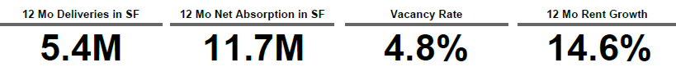

*Demand outpaced supply through the second half of 2021 and the first half of 2022, pushing the market's vacancy rate to a historic low of 4.8% overall, and even lower in logistics properties. Record levels of consumer spending and an influx of imports at Southeastern ports led to spillover demand for warehouse space in growing inland markets such as Charlotte. However, as increasing fuel costs and broader inflation reduce consumer buying power, and consumer spending shifts from goods to services, the pace of growth in demand could taper off in the near term. At the same time, more than 16.5 million SF of mostly speculative industrial space is under construction in the Charlotte market.*

*Leasing activity remains stronger than ever, though. In the first two quarters of 2021, net absorption more than doubled net new supply. Despite the surge in supply, rent growth here is tracking above the national average at 14.6% year over year, though at $7.70/SF, rents are more affordable here than in Sun Belt counterparts.*

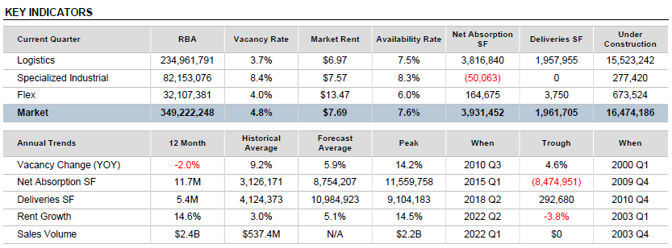

*The area surrounding the Charlotte Douglas International Airport, a hub for American Airlines, draws logistics operations and international manufacturers. As part of a redevelopment plan launched in 2015, airport and city officials have focused on developing surrounding land for light manufacturing and distribution operations. An intermodal facility at the airport offers direct access to interstate and freight rail lines, which connect to shipping channels through the ports of Charleston and Wilmington.*

*Industrial development has also followed the interstates into the suburbs. As urban land becomes scarcer and population shifts to the suburbs, developers in surrounding counties are looking to capture manufacturers and logistics operations needing space and easy access to interstates and the airport. This is especially true in the State Line, Gaston County, North, and York County submarkets.*

*Sales volume reached record levels in 2021. Investors have poured $2.3 billion into industrial properties in Charlotte over the past 12 months. Investors show continued interest in flex properties in suburban industrial parks. In urban submarkets, buyers are focused on older warehouses for conversion to housing and retail uses.*

Leasing Activity

*While* *continued speculative construction has left the overall vacancy rate above national norms at 4.8%, leasing activity is quickly filling available space. Demand for big-box logistics space has left logistics vacancies lower at 3.7%, while the market's large supply of older manufacturing space means specialized vacancies are about 8.4%.*

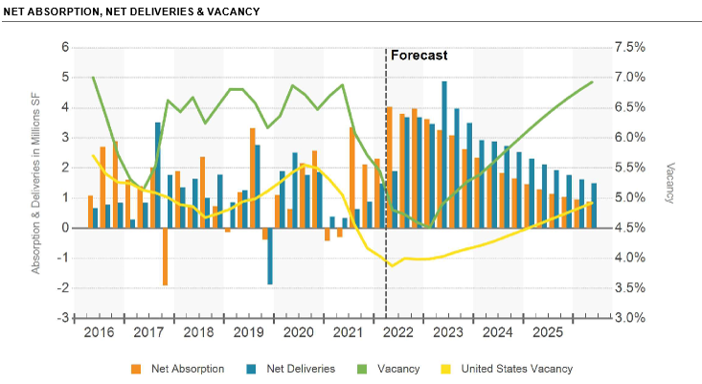

*Total leasing activity has surpassed 23 million SF from 21Q3 through 22Q2 as e-commerce distributors seek to move inventories closer to end consumers and third- party logistics providers seek strategic locations within trucking distance of large population centers and major ports.*

*Distribution operations have sought space near transportation nodes, whether close to Charlotte Douglas International Airport or in suburban locations with ample interstate access in proximity to e-commerce customers. Some of the largest recent leases and move-ins came from third-party logistics companies such as Logistics Plus and retailers such as Macy's. In March 2022, Logistics Plus signed a 497,000-SF lease at the Rock Hill Commerce Center in Rock Hill while Macy's announced plans to move into a speculative 1.4 million- SF warehouse along the Interstate 85 corridor in Rowan County when it opens in August 2023.*

*Rising demand for housing has spurred growth among supporting manufacturers and distributors. Two home improvement retailers, Home Depot and Lowe's, signed leases for additional warehouse space in Charlotte in early 2022. In Iredell County's Statesville, paint maker Sherwin Williams announced a $324 million expansion of its manufacturing and distribution center. That follows an earlier lease signed by JELD-WEN, a Fortune 1000 manufacturer of doors and windows, for a 112,000-SF manufacturing facility in Statesville. JELD-WEN is a major supplier to Lowe's Home Improvement, which is also headquartered in Iredell County.*

*Several recent lease deals and future announcements have generated buzz for the York County Submarket, which is just south of the South Carolina state line. Online rug retailer Unique Loom leased 275,960 SF in the Riverwalk Business Park in Rock Hill, part of a broader regional expansion including the addition of 234,000 SF in Lancaster County. Unique Loom joins bedding manufacturer Mlily, which signed for more than 270,000 SF in the Riverwalk Park back in March.*

*Arrival, which moved its U.S. headquarters to Charlotte's South End office submarket in 2021, also moved into its second bus microplant at the Meadow Oak Commerce Center, in the Airport West Submarket in April 2022.*

*In Cabarrus County, the redevelopment of a shuttered Phillip Morris tobacco plant into a manufacturing megasite reached critical mass. Eli Lilly announced plans to add 600 employees to manufacturer diabetes care drugs at the site, adding to earlier announcements from Red Bull, Rauch, Ball Metals, Carvana, and cabinetmaker Goldenhome.*

Rental Rates

*At $7.70/SF,* *market rents in Charlotte remain below those in Sun Belt peers such as Nashville, Raleigh, and Austin and about on par with Atlanta. That affordability has proven a selling point for manufacturing and logistics operations. Despite the heavy construction pipeline, annual rent growth, at 14.6%, has surpassed the national average.*

*Submarkets with a higher share of flex space like Mecklenburg Line, North, and Cabarrus County command a premium, while exurban submarkets with lots of new deliveries and construction underway, such as Rowan County and Gaston County, offer discounted rents.*

*Continued construction could weigh on Charlotte's rent growth in the near term, though logistics space, which has seen the most speculative construction over the past 12 months, is seeing strong rent growth at 13.5% year over year. Logistics rents vary considerably by quality, space rented, and lease term. A 1955-built 413,000-SF 2 Star industrial building in Iredell County rented to Kewaunee Scientific on a 20-year lease for $4.08/SF starting, while a 201,788 SF space in York County's Lakemont East rented to Trinity Transport for an asking rent of $5.75/SF for three years.*

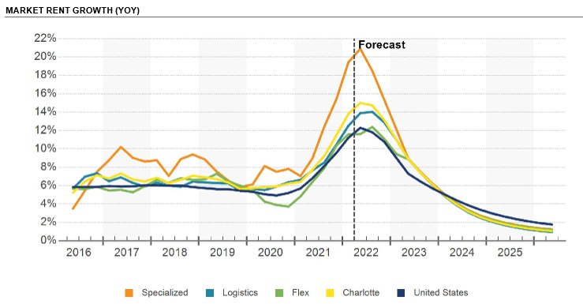

Construction Activity

*As industrial* *demand and leasing activity reached record levels in early 2022, developers ramped up the pace of construction. While only 4.9 million SF has delivered over the past 12 months, more than 16.5 million SF is currently under construction. Tenants have quickly absorbed the newest larger-footprint space, and more than 90% of space delivered since 2020 is occupied. As large retailers such as Amazon and Target have announced drawdowns in industrial space as inventories soar and rising costs cut into profits, new construction starts slowed in 22Q2 and preleasing activity has fallen to less than one-third of available space. However, some large industrial tenants in Charlotte have signed long-term deals on speculative development with delivery dates as far out as 2023. Macy's, for example, signed a 1.4 million-SF lease on a speculative development in Rowan County, which is scheduled to deliver in September 2023.*

*Rowan County is one of several suburban and exurban submarkets where industrial construction has shifted. More than two-thirds of all space under construction is in four suburban submarkets: Gaston County, State Line, North, and Rowan County. And two of the three leading submarkets for net deliveries over the past 12 months are York County and the North Submarket near Lake Norman. Three trends drove this growth — population growth, goods spending, and geography.*

*As space requirements for logistics operations increase and buildable land is increasingly hard to find, developers are seeking out greenfield sites near transportation nodes. At the same time, population growth has shifted to the suburbs, putting suburban e- commerce operations closer to their customers. The average size of industrial buildings under construction has nearly tripled since 2019 compared to the decade before.*

*Increased goods spending also led to an influx of imports at major Southeastern Ocean ports. Savannah, Georgia, and Charleston, South Carolina, which are both among the top 10 busiest ports in the United States, increased import volume by more than 20 percent in 2021.*

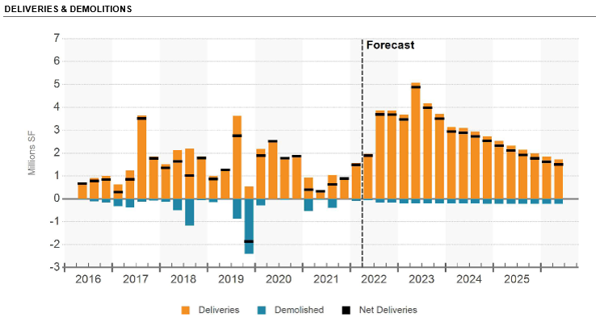

*These traditionally exports-oriented ports in smaller population centers have scrambled to expand their warehouse inventory quickly enough to store and sort those imports. Charlotte's geographic location puts it within four hours trucking distance of both ports. Charlotte's location along the I-85 corridor also puts the market within four hours of more than 14 million people. While imports growth began to level off in 22Q2, larger inventories will continue to require warehouse and distribution space in the near term.*

*Gaston County, where projects representing a 13% expansion of inventory are underway, is building on these trends as well as its proximity to Charlotte Douglas International Airport. Industrial parks including RiverWest, the Aberdeen Business Park, and the Kings Mountain Corporate Center are expected to deliver over the next few years. Gaston County has a long track record of attracting international manufacturers. Knoll America, a German industrial toolmaker, announced plans to open its United States headquarters and manufacturing facility at the recently delivered Apple Creek Corporate Center, joining plastics producer Premix and GNT. The county has approved incentives for an unnamed tenant that would invest $100 million for a purpose-built facility on the Kings Mountain Corporate Center site, expected to create more than 300 jobs.*

*In York County, South Carolina's interstate access and incentive programs continue to attract manufacturing operations both from out of state and from just across the state line. As the recently delivered Legacy Park developments continue to lease up in Rock Hill, the 1 million-SF Rock Hill Commerce Center broke ground and is expected to deliver in mid-2022. Another 1 million SF of distribution space broke ground in Fort Mill, where the Stateline 77 logistics park is scheduled to open in 2023.*

*Growth continues in more established neighboring submarkets such as Airport West and State Line. The*

*3.5 million-SF Carolina Logistics Park, set to deliver over the next year in the State Line Submarket near the York County border along Westinghouse Boulevard, signed Amazon for just more than 1 million SF. The State Line Submarket is home to several of the region's manufacturing and distribution operations. In Airport West, the partially leased, 500,000-SF Meadow Oak Commerce Center delivered in late 2021. Developers remain confident in the Airport Submarket; more than 1.1 million SF has delivered or is under construction here, and the proposal pipeline continues to grow. McCraney Properties purchased 150 acres with plans to build the 485 Logistics Industrial Park with more than 2 million SF of industrial space. In the North Submarket, crews broke ground on additional properties in the Bryton Commerce Center.*

*In Rowan County, the Northpoint Development* *announced plans for an I-85 Commerce Center, a 676,000-SF warehouse off Interstate 85's exit 70. A few exits south, the Silverman Group broke ground on the first phase of a 1.9 million-SF 85 North Logistics Center in China Grove.*

Sales Activity

*Industrial* *sales volume has reached record levels in the Charlotte market. More than $2.3 billion has traded hands in the last 12 months. The share of institutional buyers has also increased, rising to more than one-third of total sales volume over the past year.*

*Large single-tenant properties have attracted the most investor interest. California-based TPG Global purchased the 285,611-SF property in Withers Cove Business Park in May 2022 for $35 million or*

*$122.54/SF. The 2001-built property is fully occupied by janitorial supply company Essendant. In April 2022, Las Vegas-based CAI Investments purchased the 413,000- SF property at 2700 W Front St. in Statesville in a sale- leaseback deal from Kewaunee Scientific. The private equity firm paid $30.28 million, or $73.71/SF, for the 1955-built property and executed a 20-year lease with Kewaunee, generating a 6.26% pro forma cap rate.*

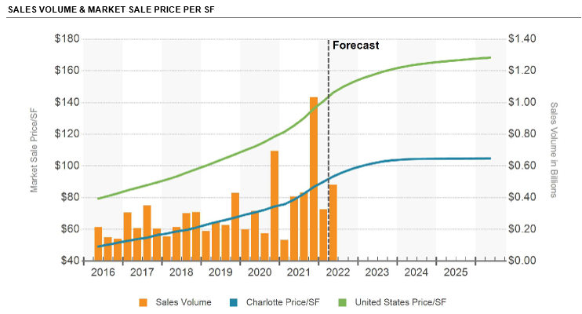

*In December 2021, German-based DWS Group purchased the 644,000-SF distribution facility in Metrolina Park, which had been custom built for FedEx earlier in 2021 by Beacon Partners. The property sold for*

*$109.5 million, or nearly $170/SF. Blackstone purchased two fully leased flex properties in the State Line Submarket as part of a 113-property, $3.2 billion national portfolio deal in October 2021. The two properties, both built in 2001 and occupied by International Paper and Chemring Solutions, sold for around $116/SF.*

*Price appreciation continues, too, as an increasing number of institutional and private equity investors target big-box assets along the I-85 corridor. In Gaston County, for example, private equity firm Artemis Real Estate Partners bought the Hanes distribution center for $33.2 million, or $71/SF. New York-based REIT Ladder Capital Finance realized a 37% return on its 2015 purchase of the 470,000-SF property, which was built in 1995.*

*Many national buyers focused on Charlotte as part of a broader Carolinas acquisition strategy. In April 2022, Chicago-based LaSalle Investment Management, an institutional investor, purchased a seven-property portfolio of industrial space in Charlotte and Durham ranging from 100,000 to 200,000 SF. Its Charlotte purchases included the Transwest Industrial Park, a 1994-built property on Westinghouse Boulevard in the State Line Submarket. The properties, which were all 100% occupied, sold for $176 million, or $172/SF, at a 3.12% cap rate, well below the marketwide rate of 6.3%. New York-based DRA Advisors purchased the 406,000- SF industrial park at 1001 Bond St. occupied by Daimler AG and Custom Polymers. The 1969-built asset sold as part of a $71 million, four-property portfolio, including two properties in Durham, North Carolina. In York County, the Pennsylvania-based private equity group Stoltz Real Estate Partners purchased a 558,900-SF building in the Lakemont Business Park for $48.5 million. The 1998-built building was fully leased to Legrand North America and Sanmina Corporation at the time of sale. Stoltz also made large acquisitions in the Asheville, North Carolina, industrial market.*

*In urban submarkets, investors continued to buy older industrial properties, most likely for adaptive reuse. In South End in October 2021, local multifamily developer Delray Ventures purchased the 20,000-SF warehouse block at 1406-1438 Winnifred St. and its 1.17-acre lot for $13 million, or $650/SF.*

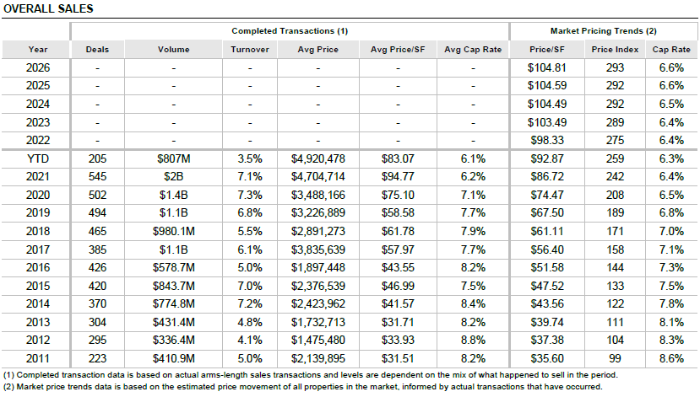

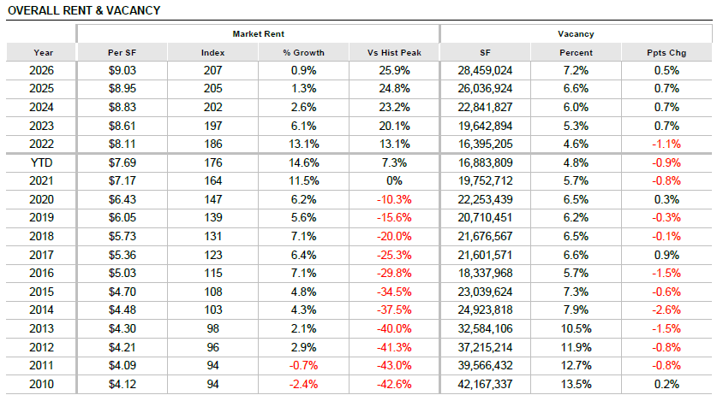

Tyvola Road Industrial Submarket

*Tyvola Rd is a midsized submarket, containing around 10.9 million SF of industrial space. Logistics is the predominant subtype here, and these facilities contain about 7.3 million SF of space. But Tyvola Rd has a sizable flex presence, as well, which accounts for 3.0 million SF of its inventory.[7]*

*The overall vacancy rate, 3.2%, has tightened by 2.4% over the past four quarters. Annual net absorption clocked in at 260,000 SF, the strongest reading in over five years.*

**

*Rents grew by 12.0% over the past 12 months, easily exceeding the 5.8% average annual change over the past decade. Industrial rents in Tyvola Rd run for about $10.40/SF, which is moderately above the metro average. A similar pattern holds for logistics space, which at $9.20/SF, rents for more than the $7.00/SF metro average for that subtype.*

*The 180,000 SF currently underway in Tyvola Rd accounts for 1.7% of inventory. While this is not the only construction the submarket has seen in recent memory, it does represent a turnabout from the overall trend. Specifically, the inventory has contracted over the past 10 years, as demolition activity has outpaced new construction.*

*Industrial properties have traded with regularity in recent years, and last year, the number of sales significantly exceeded the three-year average.*

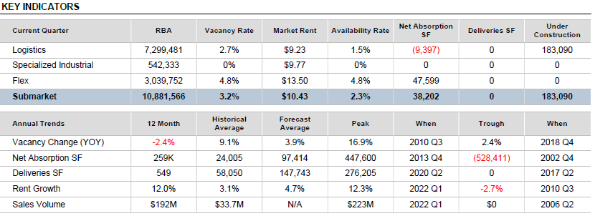

Submarket Leasing Activity

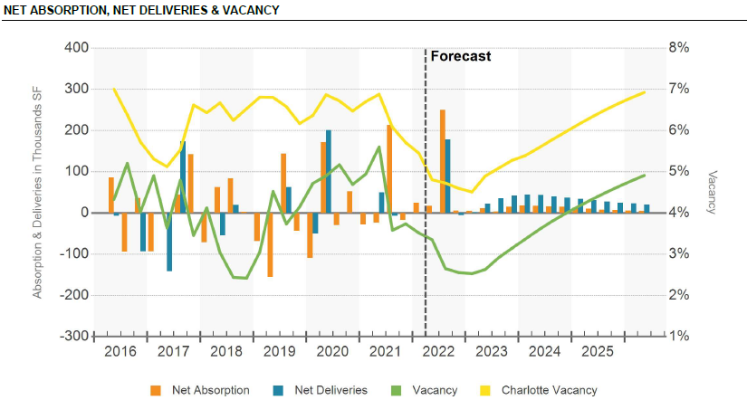

Submarket Rental Rates

*Industrial rents in Tyvola Rd run for about $10.40/SF, which is considerably above the metro average. A similar pattern holds for logistics space, which at $9.20/SF, rents for well above the $7.00/SF metro average for that subtype.*

*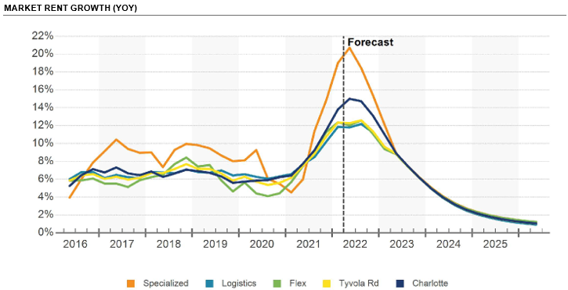Rents grew at an impressive rate of 12.0% over the past 12 months. This growth rate was close to the highest annualized rate in the past three years.*

*The Tyvola Rd Submarket has experienced transformative levels of rent growth over the past decade. Industrial rents today are 81.0% higher than they were 10 years ago. Remarkably, that still falls short of the corresponding 85.3% increase in the Charlotte metro at large over the past decade.*

Submarket Construction Activity

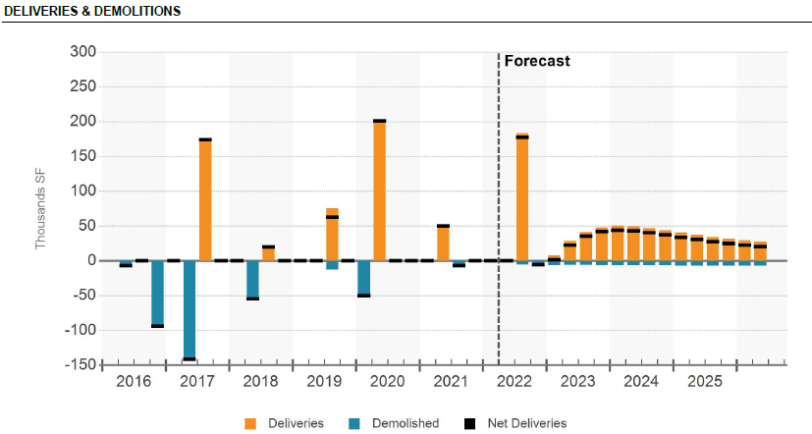

Submarket Sales Activity

*Industrial* *investors have been very active in the capital markets in Tyvola Rd, making it one of the most heavily traded industrial areas in the region over the past several years. Annual sales volume has averaged $92.1 million over the past five years, and the 12-month high in investment volume hit $223 million over that stretch. In the past 12 months specifically, $193 million worth of assets sold. Deals involving logistics properties drove recent sales volume.*

*The market pricing, based on the estimated price movement of all industrial properties in the submarket, sat at $134/SF during the second quarter of 2022. That price has surged since last year, growing by more than 10%, and the price itself is a significant premium relative to the average pricing for the Charlotte region. The market cap rate has dropped since last year. It is the lowest cap rate that has been seen in five years, and it's close to the metro's average.*

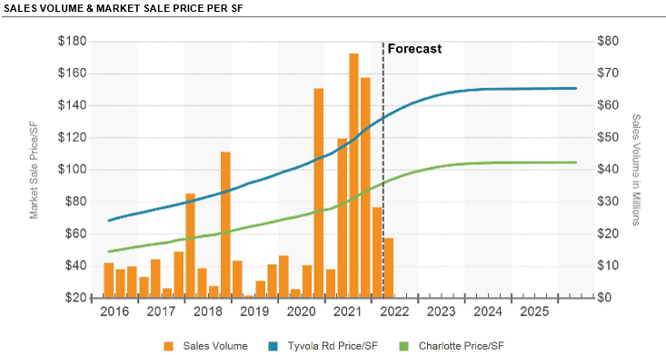

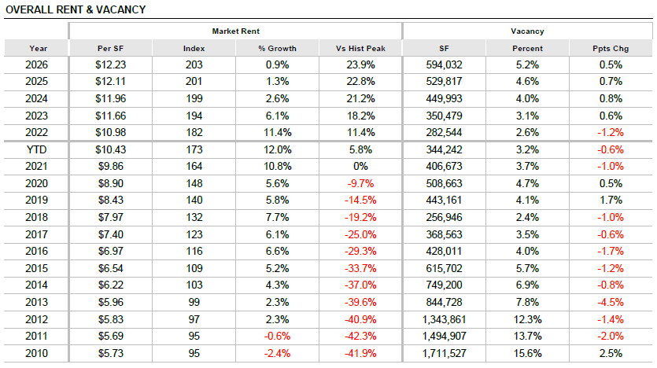

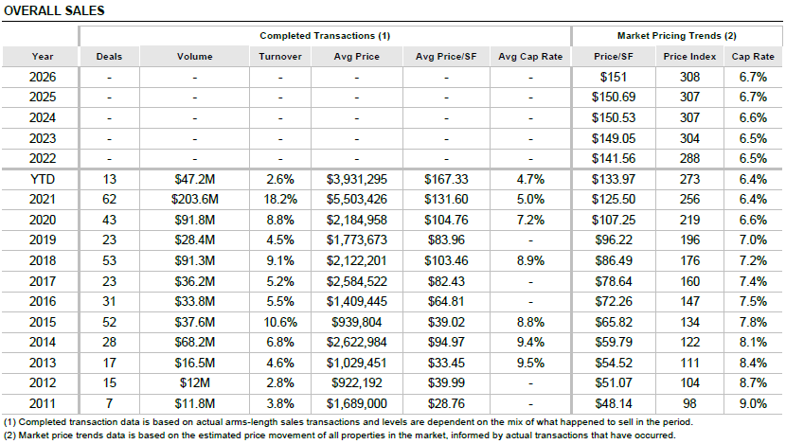

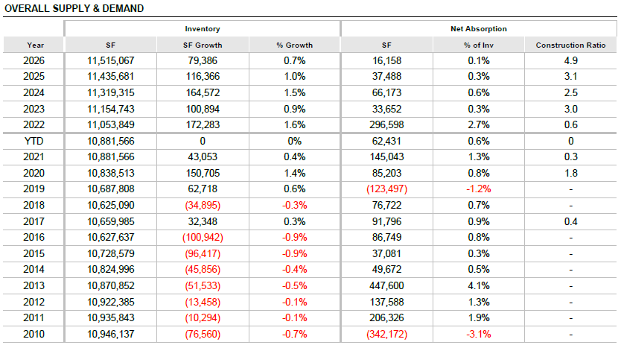

# SITE DESCRIPTION

Physical Characteristics

|  |  |
| --- | --- |
| Location | 4735 Dwight Evans Road  Charlotte, North Carolina 28217  The subject is located on the southeast side of Dwight Evans Road within the city limits of Charlotte in Mecklenburg County, North Carolina. |
|  |  |
| Census Tract | 0038.02 |
|  |  |
| MSA/MD | Charlotte-Concord-Gastonia, NC-SC |
|  |  |
| Total Condominium Site Area | 2.59 Acres 112,820 SF |
|  |  |
| Site Shape | Irregular |
|  |  |
| Topography | Gently sloping |
|  |  |
| Surplus/Excess Land | None noted |
|  |  |
| Soil Conditions | We were not provided a soil report for review. The soils that comprise the subject site appear to be of adequate support and permeability to support the existing and/or proposed structure(s). We did not observe any evidence to the contrary during our physical inspection of the property. |
|  |  |
| Environmental Considerations | We are not aware of any known source of pollution or environmental hazards noted in the area. As no gross evidence of contamination was observed, this report assumes that the site is free of contaminants. The opinion of value in this report is contingent upon no environmental hazards on or around the subject site. |
|  |  |
| Site Utility | Average |
|  |  |
| Location Rating | Good |

Utilities

|  |  |
| --- | --- |
| Water | Available |
|  |  |
| Sewer | Available |
|  |  |
| Electricity | Available |
|  |  |
| Gas | Available |

Legal Information

|  |  |
| --- | --- |
| Parcel Number(s) | 145-301-22 |
|  |  |
| Current Owner | Investcore Prop Co 9, LLC |
|  |  |
| Current Zoning | I-2, Heavy Industrial District  City of Charlotte |
|  |  |
| Flood Zone | *X or C Zone*: Area of minimal flood hazard, usually depicted on FIRMs as above the 500‐year flood level. Zone C may have ponding and local drainage problems that don't warrant a detailed study or designation as base floodplain. Zone X is the area determined to be outside the 500‐year flood and protected by levee from 100‐year flood. |
|  |  |
| Flood Map | FEMA Flood Insurance Rate Map, Community Panel 37119C4532K dated September 2, 2015 |
|  |  |
| Wetlands/Watershed | None noted |
|  |  |
| Easements/Encroachments | We are not aware of any easements or encroachments which would adversely affect the utilization of the site. |
|  |  |
| Preliminary Title Report | An authoritative report of title was not provided for review. |

Surrounding Arterials

|  |  |
| --- | --- |
|  | Dwight Evans Road |
| Access/Exposure |  |
| Type of Street | Secondary |
| No. of Lanes | Two |
| Frontage | 265.77 feet |
| Access | Direct |
| No. of Curb Cuts | One |
| Improvements |  |
| Curbs | Yes |
| Gutters | Yes |
| Sidewalks | No |
| Street Lighting | No |
| Median | No |
| Street Parking | No |

Flood Zone Map

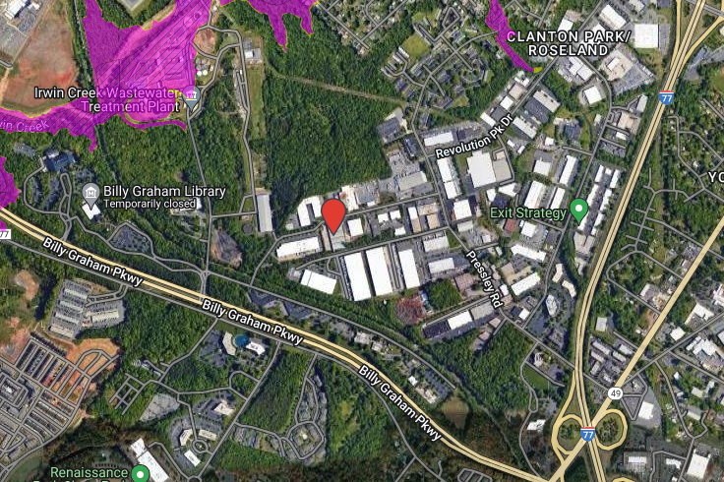

Parcel Map

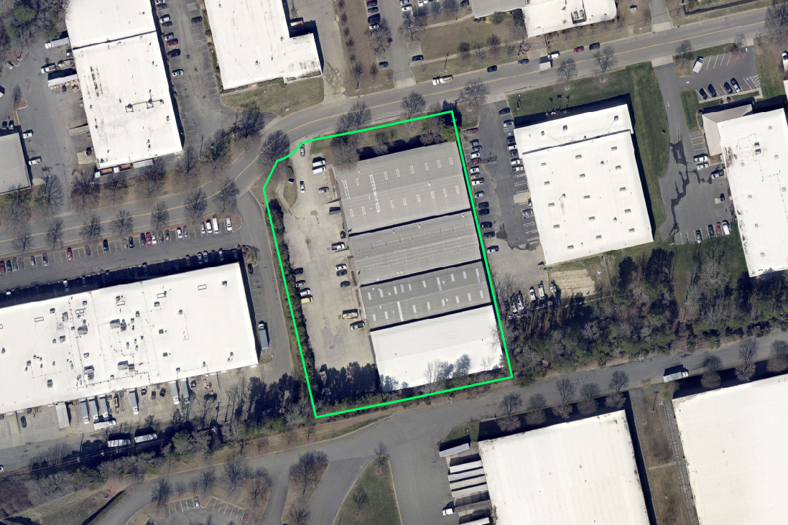

# IMPROVEMENTS DESCRIPTION

General Description

|  |  |
| --- | --- |
| Property Type(s) | General Purpose Warehouse |
|  |  |
| Property Subtypes(s) | Bulk Warehouse |
|  |  |
| No. of Buildings | One |
|  |  |
| No. of Stories | One |
|  |  |
| Year(s) Built | 1989 |
|  |  |
| Construction Class | Class S, Structural Steel-Frame |
|  |  |
| Construction Quality | Average |
|  |  |
| Gross Building Area (SF) | 16,268 |
|  |  |
| Rentable Area (SF) | 16,268 |
|  |  |
| Eave Height | 18 feet |
|  |  |
| Ceiling Height | 21 feet |
|  |  |
| Column Spacing | 45’ x 20’ |
|  |  |
| Finished Office Area (SF) | 1,209 |
|  |  |
| Finished Ratio | 7.4% |
|  |  |
| Mezzanine (SF) | None |
|  |  |
| Truck Court | 92 feet |
|  |  |
| Loading: |  |
| Grade-Level | None |
| Dock-high | Three (10’ height x 8’ width) |
|  |  |
| Loading SF/Door | 5,423 |
|  |  |
| Occupancy | Vacant |
|  |  |
| Condominium Coverage Ratio | 51.2% |
| Parking Type | Surface |
|  |  |
| Condominium Parking Spaces | 53 |
|  |  |
| Parking Ratio | 0.92 spaces/1,000 SF |

Construction Details

|  |  |
| --- | --- |
| Foundation | Poured concrete slab |
|  |  |
| Construction | Structural steel-framed; Masonry |
|  |  |
| Exterior Walls | Painted CMU and stucco |
|  |  |
| Roof | Gable with metal standing seam. The appraiser was not provided access to the roof. |
| Windows | Anodized aluminum frame |
|  |  |
| Entry Doors | Glass storefront and metal |
|  |  |
| Ventilation | Appears adequate |
|  |  |
| Insulation | Appears adequate |
|  |  |

Interior Elements

|  |  |
| --- | --- |
| Interior Layout | Finished office, warehouse |
|  |  |
| Walls | Metal panels with insulation  Wood-frame drywall partitioning |
|  |  |
| Flooring | Polished concrete; commercial grade carpeting |
|  |  |
| Lighting | Fluorescent |
|  |  |
| Restrooms | One, two-fixture |
|  |  |

Mechanical Systems

|  |  |
| --- | --- |
| Heating | Gas FWA |
|  |  |
| Cooling | Package Units |
|  |  |
| Electrical | 3-Phase, 480/277 volts, 1200 amps |
|  |  |
| Plumbing | Standard piping and hot water systems assumed |

Special Improvements

|  |  |
| --- | --- |
| Fire Protection | None noted. The building is not equipped with fire sprinklers |
|  |  |
| Elevators | None |
|  |  |
| Security | None noted |
|  |  |
| Signage | Monument sign |
|  |  |
| Personal Property/FF&E | Personal property has been excluded in this analysis. |

Quality and Condition

|  |  |
| --- | --- |
| Functional Utility | No major items of functional obsolescence observed. |
|  |  |
| Condition | Average |
|  |  |
| Deferred Maintenance | None noted |
|  |  |
| Actual Age | 33 years |
|  |  |
| Effective Age | 10 years |
|  |  |
| Economic Life | 40 years |
|  |  |
| Remaining Economic Life | 30 years |
|  |  |
| Comments | The estimate of effective age is based on qualitative comparison between the subject and competitive properties in the market. |

Bu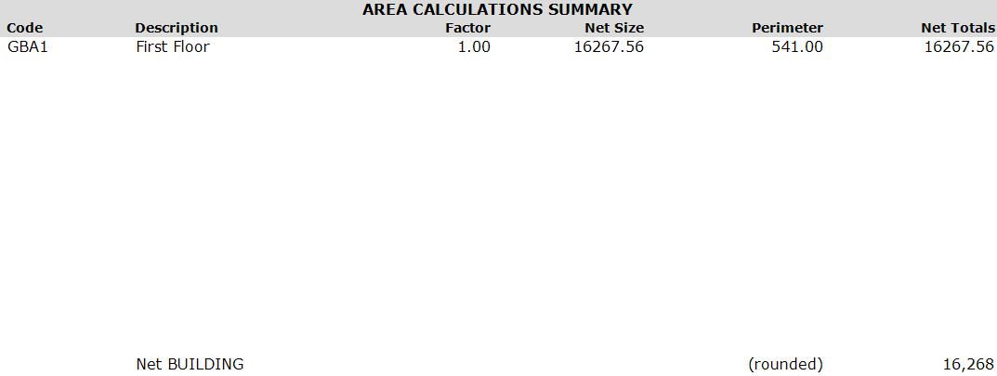ilding Sketch

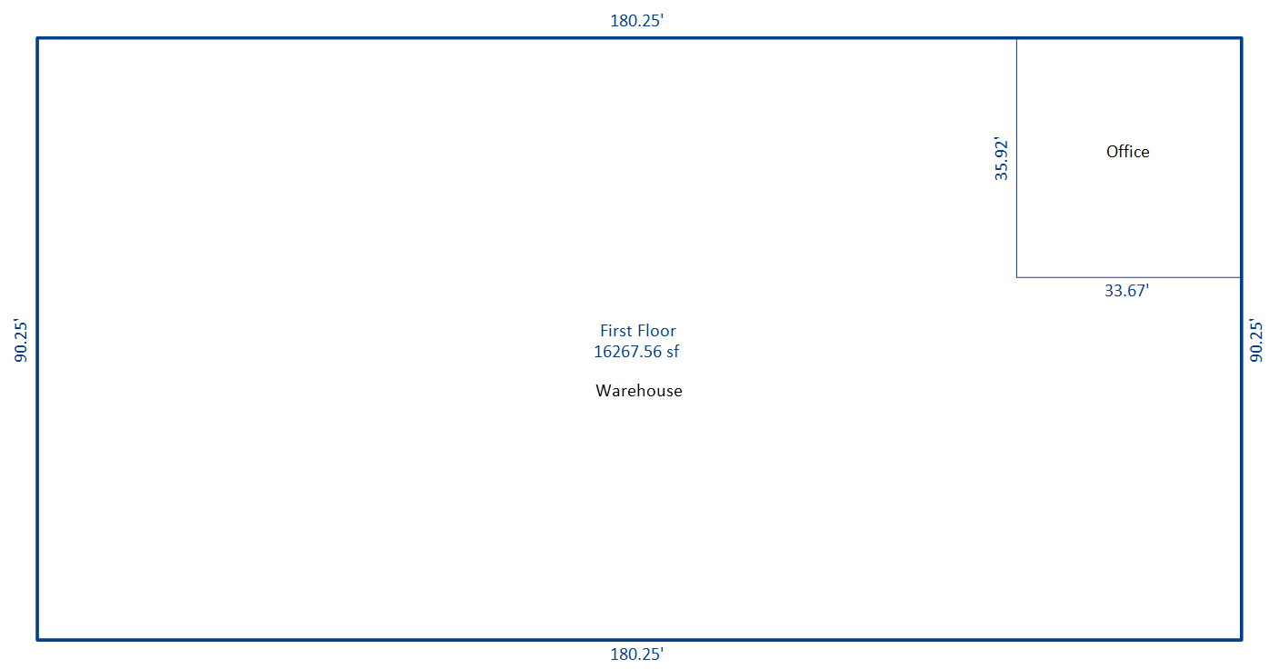

# ZONING

Zoning Summary

|  |  |
| --- | --- |
| Zoning Jurisdiction | City of Charlotte |
|  |  |
| Zoning Designation | I-2, Heavy Industrial District |
|  |  |
| Purpose | The I-2, Heavy Industrial District is established to create and protect wholesaling and industrial areas for manufacturing, processing and assembling of parts and products, distribution of products at wholesale, transportation terminals, and a broad variety of specialized industrial operations. |
|  |  |
| Legally Conforming? | Appears to be legally conforming |
|  |  |
| Zoning Change Likely? | No |
|  |  |
| Types of Permitted Uses | Industrial; Retail; Office; Institutional; Hospitality |

Development Standards

|  |  |
| --- | --- |
| Minimum Lot Area | 8,000 SF |
|  |  |
| Minimum Lot Width | 50 feet |
|  |  |
| Minimum Front Yard Setback | 20 feet |
|  |  |
| Minimum Side Yard Setback | None |
|  |  |
| Minimum Rear Yard Setback | 10 feet |
|  |  |
| Maximum Building Height | 40 feet |
|  |  |
| Maximum FAR | 1.0 |

Zoning Map

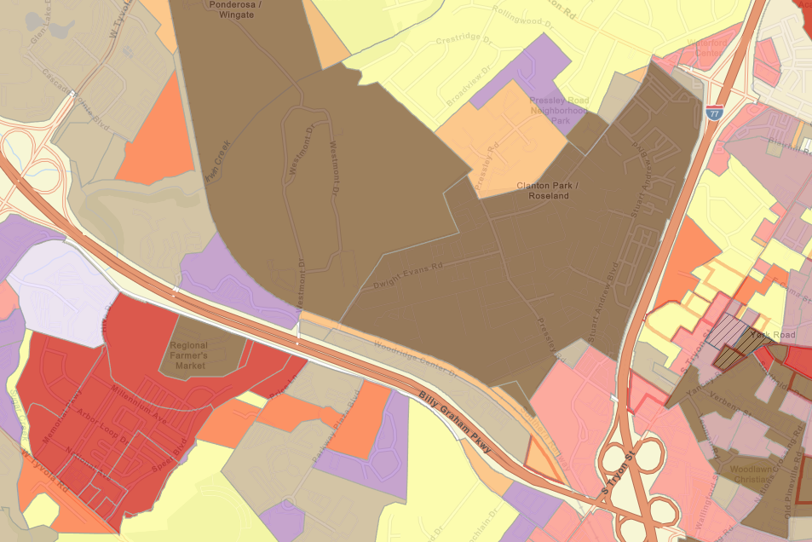

# REAL ESTATE TAXES AND ASSESSMENT

Introduction

In North Carolina, all real property types similar to the subject are required to be assessed at 100% of the fair market value unless otherwise specified by law. Property is assessed at the county level by the Property Assessors Office.

Current Property Tax Liability

The subject property is under the tax jurisdictions of Charlotte and Mecklenburg County, North Carolina. The 2021 millage rate for properties located in Charlotte and Mecklenburg County was $0.965 per $100 of assessed value. The following table summarizes the 2021 property tax liability for the subject property.

|  |  |
| --- | --- |
| Parcel No(s). | 145-301-22 |
| Tax Year | 2021 |
| Tax-Appraised Value: |  |
| Land Value | $0 |
| Improvement Value | $1,055,600 |
| Accessory Value | $0 |
| Total Tax-Appraised Value | $1,055,600 |
| Times 100% Assessment | 1.00 |
| Assessed Value | $1,055,600 |
| Times Millage Rate | 0.00965 |
| Total Property Taxes | $10,186.54 |

Property taxes are due each year on September 1st. According to the Mecklenburg County Tax Administration Office, the 2021 taxes for the subject property have been paid.

# HIGHEST AND BEST USE

Introduction

Highest and best use is defined as the reasonably probable and legal use of vacant land or an improved property.[8]

The four criteria the highest and best use must meet are:

* + Legal Permissibility – a property use that is either currently allowed or most probably allowable under zoning codes, building codes, environmental regulations, and other applicable laws and regulations that govern land use;
  + Physical Possibility – the land must be able to accommodate the size and shape of the ideal improvement;
  + Financial Feasibility – the ability of a property to generate sufficient income to support the use for which it was designed; and
  + Maximum Productivity – the selected land use must yield the highest value of the possible uses.

Highest and Best Use as Vacant

*Legally Permissible*

The zoning regulations in effect at the time of the appraisal determine the legal permissibility of a potential use of the subject site. As described in the Zoning Section of this report, the subject site is zoned I-2, Heavy Industrial District by the city of Charlotte. The purpose of this district is to create and protect wholesaling and industrial areas for manufacturing, processing and assembling of parts and products, distribution of products at wholesale, transportation terminals, and a broad variety of specialized industrial operations.

Additionally, given the character of the area and the location of the subject within the district, a change in zoning is considered improbable.

*Physically Possible*

The physical possibility of a use is dictated by the size, shape, topography, availability of utilities, and any other physical aspects of the site. The condominium park site contains 2.59 acres or 112,820 square feet. The site is irregular in shape with gently sloping topography. The subject site has 265.77 feet of frontage along Dwight Evans Road with average exposure. All utilities are available to the site. The physical characteristics are considered adequate to accommodate most types of permitted development.

*Financially Feasible and Maximally Productive*

Financially feasible uses are those uses that can generate an income or return greater than or equal to the costs of development. Of the uses that are permitted, possible, and financially feasible, the one that will result in the maximum value for the property is considered the highest and best use.

Conclusion

We considered the legal issues related to zoning and legal restrictions. We also analyzed the physical characteristics of the site to determine what legal uses would be possible and considered the financial feasibility of these uses to determine the use that is maximally productive. Considering the subject site’s physical characteristics and location, as well as the state of the local market, it is our opinion that the Highest and Best Use of the subject site as vacant is industrial use developed in accordance with the predominant supply and demand characteristics of the local market.

Highest and Best Use as Improved

*The Dictionary of Real Estate Appraisal* defines highest and best use of the property as improved as:

The use that should be made of a property as it exists. An existing improvement should be renovated or retained as is so long as it continues to contribute to the total market value of the property, or until the return from a new improvement would more than offset the cost of demolishing the existing building and constructing a new one.

*Legally Permissible*

As described in the Zoning Section of this report, the subject site is zoned I-2, Heavy Industrial District by the city of Charlotte. The site is improved with an industrial warehouse building containing 16,268 square feet of gross building area which is a permitted use under this zoning designation.

*Physically Possible*

The subject improvements are considered to be in average condition and appear be adequately maintained. There are no apparent major items of functional obsolescence or deferred maintenance. We know of no current or pending municipal actions or covenants that would require a change to the current improvements.

*Financially Feasible and Maximally Productive*

In our opinion, the improvements provide a substantial value contribution to the property as a whole. Therefore, continued use of the existing improvements is financially feasible. The maximally productive use of the subject property as improved is for continued use of the existing improvements.

Most Probable Buyer

The most probable buyer of the subject property would be an owner-occupant.

# VALUATION PROCESS

Methodology

The thee generally accepted approaches to developing an opinion of value are the Cost Approach, the Sales Comparison Approach and Income Capitalization Approach. The applicability of each approach is considered based on the quality of market data and the motivation of market participants. The type and reliability of data and the applicability of each approach is then considered and reconciled into a final value estimate.

Cost Approach

The Cost Approach is based on the principle of substitution, where an informed purchaser would pay no more for the subject than the cost to produce a substitute property with equivalent utility. This approach is particularly applicable when the property being appraised involves relatively new improvements which represent the highest and best use of the land or when relatively unique or specialized improvements are located on the site for which market data of comparable properties is difficult to obtain. The Cost Approach is also appropriate when existing improvements are reaching the end of their economic life and/or when the underlying land comprises the majority of the total property value. In these instances, the Cost Approach isolates the largest component of value by developing a full evaluation of the underlying land.

Sales Comparison Approach

The Sales Comparison Approach is also based on the principle of substitution. This approach uses a market-based unit of comparison such as price per square foot, price per unit, etc. for analysis of the sales. The strength of this approach is its wide market acceptance among investors who often evaluate comparable properties on a price per unit means of comparison. In this approach, sales of comparable properties are identified and then adjustments are applied to the unit of comparison from an analysis of comparable sales. The adjusted unit of comparison is then used to derive an opinion of value for the subject property.

Income Capitalization Approach

The Income Capitalization Approach reflects the subject property’s income-producing capabilities. This approach is based on the assumption that value is created by the expectation of benefits to be derived in the future. The two common valuation techniques associated with the Income Capitalization approach are direct capitalization and discounted cash flow (DCF) analysis.

Summary

In appraising the market value of the subject property, all three methods that apply to real estate can be utilized. In this report, we analyze the appraised property using the Sales Comparison and the Income Capitalization Approach. The exclusion of the Cost Approach is a result of the significant value contribution provided by the existing improvements and the difficulty in preparing a reliable estimate of depreciation.

The Income Capitalization Approach involves the valuation of the property in terms of its ability to generate a net operating income. Market rent was utilized for the subject’s forecasted operating statement. After estimating gross income, deductions were made for ownership and operational expenses. The resulting net operating income was then converted into an indication of value by means of direct capitalization. This methodology is employed by typical market participants for properties similar to the subject. This approach was given supportive consideration in the reconciliation.

The Sales Comparison Approach represents the primary method by which the fee simple interest in similar properties is evaluated. Properties similar to the subject are frequently sold in the local market providing sufficient data to form a credible opinion of market value. This approach was given primary consideration in the reconciliation.

# SALES COMPARISON APPROACH

Summary of Comparable Improved Sales Data

|  |  |  |  |  |  |  |
| --- | --- | --- | --- | --- | --- | --- |
|  | Subject | Sale 1 | Sale 2 | Sale 3 | Sale 4 | Sale 5 |
| Location Details |  |  |  |  |  |  |
| Address | 4735 Dwight Evans Rd | 10725 John Price Rd | 1508 Industrial Dr | 138 Cedar Pointe Dr | 227 Old Hebron St | 1020 Forsyth Ave |
| Charlotte, NC | Charlotte, NC | Matthews, NC | Mooresville, NC | Charlotte, NC | Indian Trail, NC |
| Parcel No.(s) | 145-301-22 | 201-181-27 | 193-211-07 | 4648-90-4665.000 | 205-171-24 | 07-081-303 |
| Transaction Data |  |  |  |  |  |  |
| Date of Sale |  | 5/17/2022 | 12/17/2021 | 5/25/2020 | 10/15/2020 | 5/26/2020 |
| Sale Price |  | $2,275,000 | $1,845,000 | $1,575,000 | $1,725,000 | $1,775,000 |
| Price/SF |  | $115.99 | $143.69 | $103.62 | $134.01 | $123.26 |
| Grantor |  | MSE Center LLC | Match Properties, LLC | D&G Realty, LLC | OHR Properties, LLC | Pierson Enterprises, LLC |
| Grantee |  | Sand Fiddlers Partners, LLC | Wilkat, LLC | 138 Cedar Pointe, LLC | Hop Holdings, LLC | Oakway Properties, LLC |
| Property Rights |  | Leased Fee | Fee Simple | Fee Simple | Fee Simple | Leased Fee |
| Occupancy ATOS |  | 50% | Vacant | Vacant | Vacant | 67% |
| Verification |  | Listing Broker | Listing Broker | Listing Broker | Listing Broker | Listing Broker |
| Physical Attributes |  |  |  |  |  |  |
| Gross Building Area (SF) | 16,268 | 19,614 | 12,840 | 15,200 | 12,872 | 14,400 |
| Year Built | 1989 | 1988 | 1986 | 2001 | 1989 | 2008 |
| Site Size (SF) | 112,820 | 60,984 | 105,981 | 60,113 | 87,120 | 100,624 |
| Coverage Ratio | 51.2% | 32.2% | 12.1% | 25.3% | 14.8% | 14.3% |
| Office Ratio | 7.4% | 22.5% | 27.3% | 27.6% | 31.0% | 49.6% |
| Quality | Average | Average | Average | Average | Average | Average |
| Effective Age/Condition | 10 years | 10 years | 10 years | 10 years | 10 years | 5 years |
| Access | Good | Good | Good | Good | Good | Good |
| Parking Ratio | 0.92/1,000 SF | 1.48/1,000 SF | 0.78/1,000 SF | 2.17/1,000 SF | 1.09/1,000 SF | 1.94/1,000 SF |
| Eave Height | 18 feet | 20 feet | 18 feet | 18 feet | 21 feet | 18 feet |
| Loading | 0 GL/3 DH | 1 GL/3 DH | 1 GL/2 DH | 3 GL/1 DH | 1 GL/2 DH | 3 GL/2 DH |
| Loading SF | 5,423 | 4,904 | 4,280 | 3,800 | 4,291 | 2,880 |
| Other | None | None | None | None | Ancillary Bldg. | None |

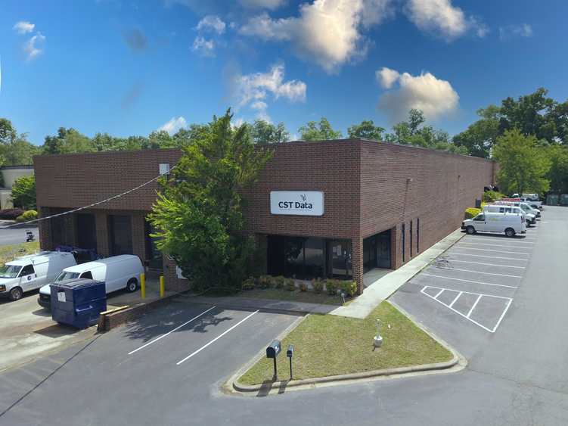

Comparable Sale 1

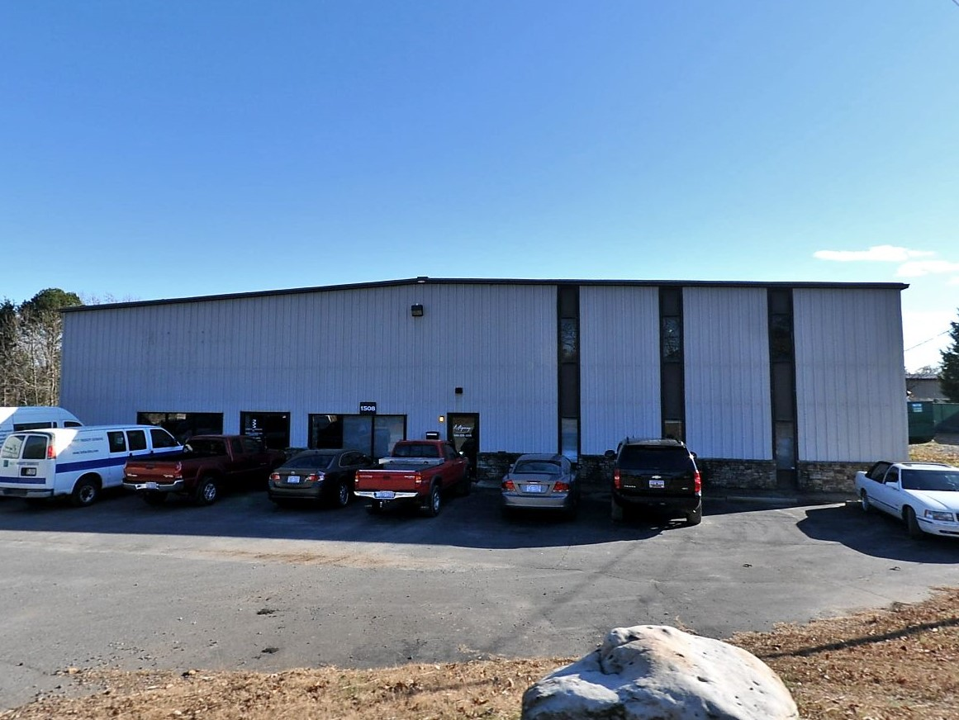

Comparable Sale 2

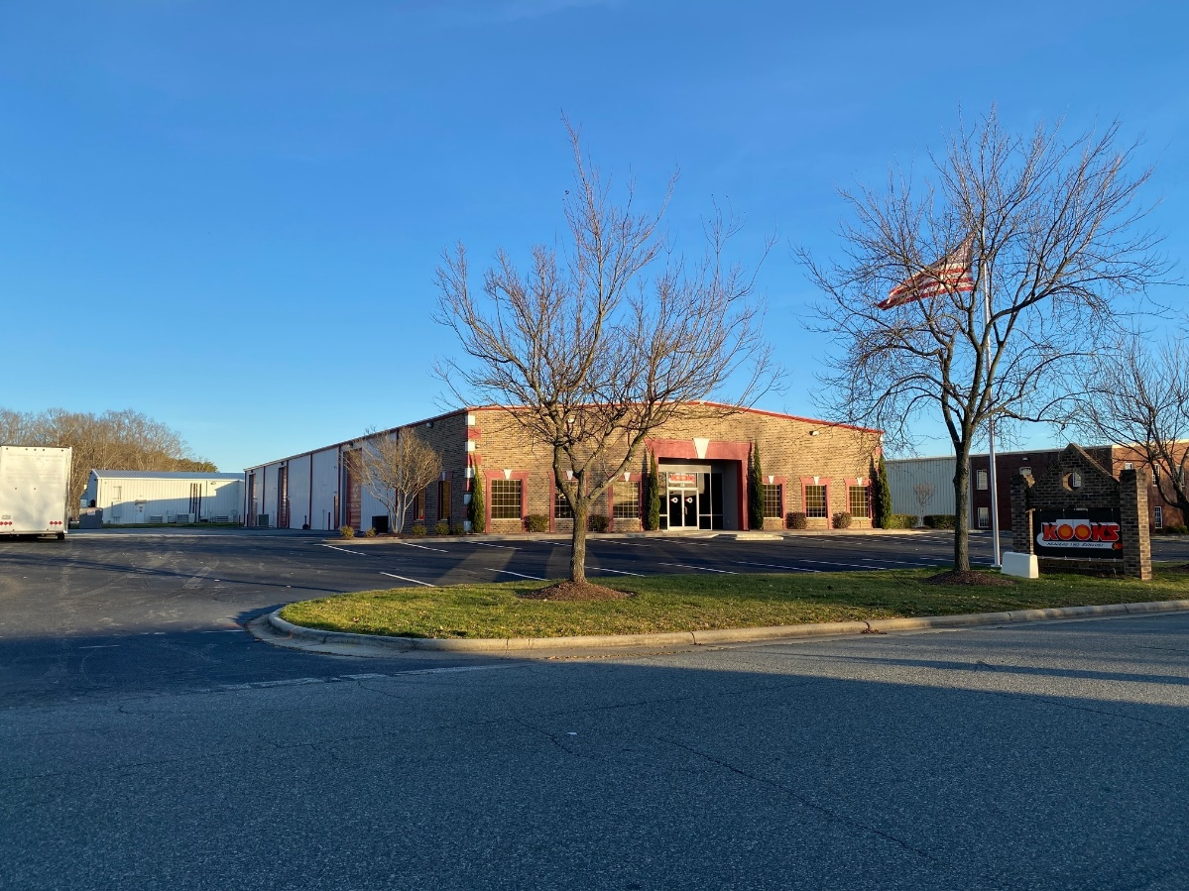

Comparable Sale 3

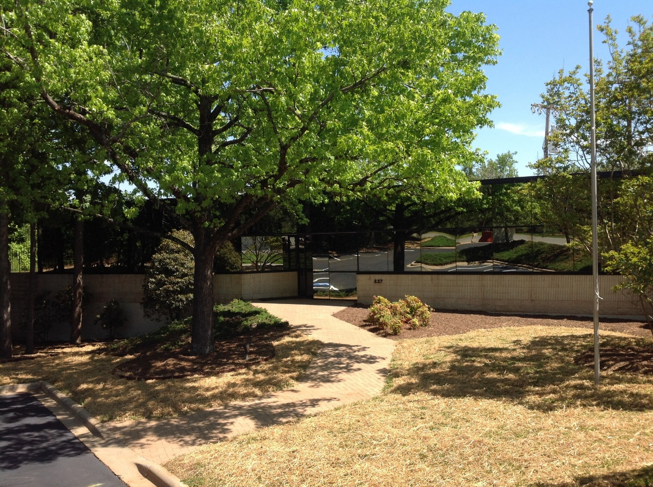

Comparable Sale 4

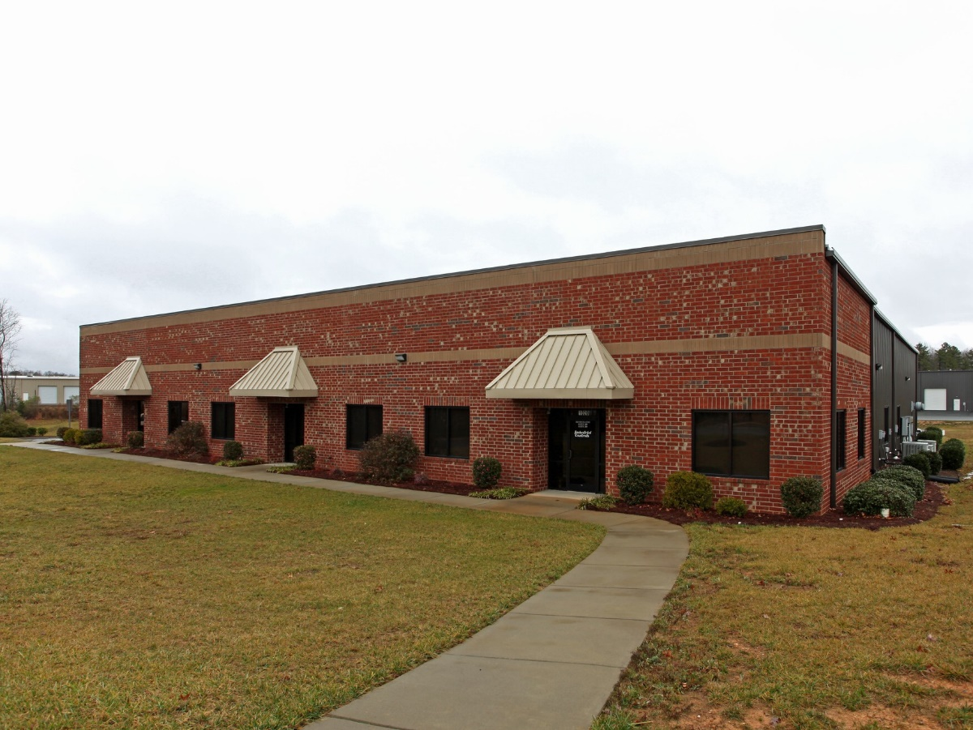

Comparable Sale 4

Comparable Sale 5

Comparable Improved Sales Map

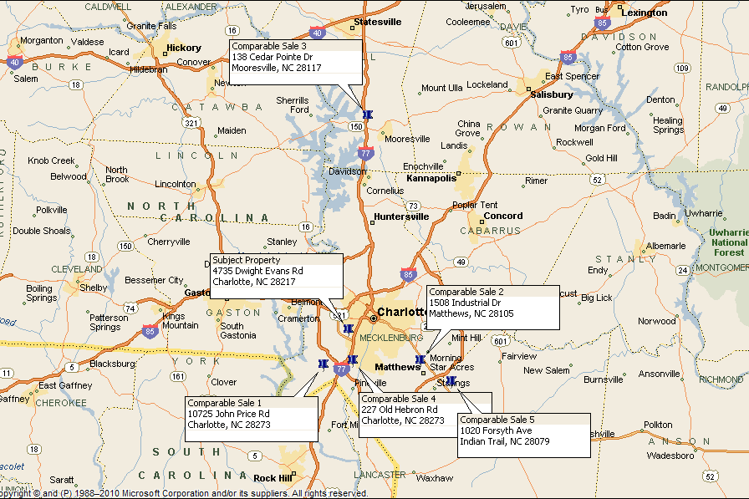

~@12

|  |  |  |
| --- | --- | --- |
|  | Subject | Sale 1 |
| Address | 4735 Dwight Evans Rd | 10725 John Price Rd |
| Charlotte, NC | Charlotte, NC |
| Sale Price |  | $2,275,000 |
| Gross Building Area (SF) | 16,268 | 19,614 |
| Price/SF |  | $115.99 |
| Transactional Adjustments |  |  |
| Property Rights |  | Leased Fee |
| Adjustment |  | 0.0% |
| Adjusted Sale Price/SF |  | $115.99 |
| Cash Equivalency |  | Assumed Market |
| Adjustment |  | 0.0% |
| Adjusted Sale Price/SF |  | $115.99 |
| Conditions of Sale |  | poopy |
| Adjustment |  | 0.0% |
| Adjusted Sale Price/SF |  | $115.99 |
| Market Conditions |  | May-22 |
| Adjustment |  | 0.3% |
| Adjusted Sale Price/SF |  | $116.37 |
| Property Adjustments |  |  |
| Location |  | 5.0% |
| Gross Building Area (SF) | 16,268 | 5.0% |
| Coverage Ratio | 51.2% | 0.0% |
| Office Ratio | 7.4% | -2.0% |
| Quality | Average | 0.0% |
| Effective Age/Condition | 10 years | 0.0% |
| Access | Good | 0.0% |
| Parking Ratio | 0.92/1,000 SF | 0.0% |
| Eave Height | 18 feet | -1.0% |
| Loading | 0 GL/3 DH | 0.0% |
| Other | None | 0.0% |
| Net Adjustment |  | 7.0% |
| Adjusted Sale Price/SF |  | $124.52 |

Comparable Improved Sales Analysis

*Property Rights Conveyed*

Adjustments for interests conveyed are required when the subject and comparable sale transactions have variable rights transferred. The comparable sales analyzed included both owner-user and investment sales. The reported leases appear to be leased near market rents. No adjustments were deemed necessary after comparison of the adjusted sales.

*Financing/Cash Equivalency*

Data related to mortgage rates for the comparable sale transactions were unavailable, but most appear to have been financed with new conventional loans or purchased all-cash. It is assumed that the financing terms for the comparable sale transactions were market-oriented. No adjustments have been applied under this category.

*Conditions of Sale*

Market value of the subject property is based on the premise of an arms-length transaction for properties exposed to the market for a reasonable length of time. All of the comparable sales are believed to be arms-length transactions or sold at market value.

*Market Conditions*

This category of adjustment is related to differences in general property values between the comparable sales date and the effective date of value. Changes in market conditions may result from various influences such as supply and demand, interest rates, employment, availability of financing, and inflationary or deflationary forces.

According to CoStar Group[9], the Charlotte industrial market has experienced declining vacancy rates and increasing rental rates for the last several quarters. Likewise, pricing of industrial properties in the market has trended upward over the same period as discussed in the *Market Analysis* section of this report. In this instance, we utilize upward adjustments to the comparable sales based on an estimated price appreciation of 1.0% per quarter.

*Location*

This category of adjustment is intended to reflect differences in the locational characteristics of the comparable properties with respect to attributes such as proximity to supporting uses and transportation routes, supply and demand trends, and the general character or reputation of the market area.

The differences in rental rates can be used as a rough proxy for general differences in pricing of industrial properties based on location. Differences in inventory, average building size, and average age of the comparable rental submarkets relative to the subject submarket were considered.

The chart below shows the respective markets and their average asking rental rates.

|  |  |  |  |  |
| --- | --- | --- | --- | --- |
| *Property* | *Submarket* | *Avg. Asking Rent* | *Implied Adjustment* | *Applied Adjustment* |
| *Sale 4* | *South* | *$14.60* | *-40%* | *-10%* |
| *Sale 2* | *East* | *$10.67* | *-2%* | *0%* |
| *Subject* | *Tyvola Rd* | *$10.43* | *-* | *-* |
| *Sale 5* | *Union County* | *$8.24* | *21%* | *5%* |
| *Sale1* | *State Line* | *$8.06* | *23%* | *5%* |
| *Sale 3* | *Iredell County* | *$7.00* | *33%* | *10%* |

*Building Size*

Differences in this category are attributable to the concept of diminishing marginal utility whereby larger properties would sell for a lower price per unit than smaller properties and vice versa. The following table summarizes the adjustments applied to the comparable sales. The following table summarizes the adjustments applied to the comparable sales.

|  |  |  |  |
| --- | --- | --- | --- |
|  | *Gross Building Area (SF)* | *Difference (SF)* | *Applied Adjustment* |
| *Sale 1* | *19,614* | *3,346* | *5%* |
| *Subject* | *16,268* | *-* | *-* |
| *Sale 3* | *15,200* | *1,068* | *-2%* |
| *Sale 5* | *14,400* | *1,868* | *-3%* |
| *Sale 4* | *12,872* | *3,396* | *-5%* |
| *Sale 2* | *12,840* | *3,428* | *-5%* |

*Coverage Ratio*

The subject’s condominium site contains four industrial buildings comprising a total of 57,780 square feet of gross building area situated on a 112,820-square-foot site, resulting in a coverage ratio of 51.2%. We considered location, frontage, and orientation of the existing improvements in estimating the contributory values of the land differentials for each the comparable sales. Comparable Sale 2 is considered superior in this respect and adjusted downward accordingly. Comparable sales 4 and 5 have superior ratios relative to the subject but are diminished by inferior topography and site shape, respectively. As such, no adjustments are deemed necessary. All the other comparable sales are considered sufficiently similar in this respect with no adjustments necessary.

*Office/Showroom Ratio*

The subject building is improved with 1,209 square feet of retail/showroom area which equates to a finished ratio of 7.4%. Adjustments for differences in finished ratios are based on a contributory value estimate of $15 per square foot. The adjustments applied under this category are exhibited in the following table.

|  |  |  |  |  |  |
| --- | --- | --- | --- | --- | --- |
| *Comparable Sale* | *1* | *2* | *3* | *4* | *5* |
| *Office Differential (SF)\** | *-2,954* | *-2,546* | *-3,070* | *-3,031* | *-6,076* |
| *Contributory Value $15/SF* | *-$44,315* | *-$38,186* | *-$46,056* | *-$45,471* | *-$91,137* |
| *Sale Price* | *$2,275,000* | *$1,845,000* | *$1,575,000* | *$1,725,000* | *$1,775,000* |
| *Implied Adjustment* | *-2%* | *-2%* | *-3%* | *-3%* | *-5%* |

*\*Difference between the subject’s finished ratio applied to the comparable and the comparable finished space.*

*Quality*

Differences in construction, quality and appeal are considered in this category. All the comparable sales are considered sufficiently similar in this respect with no adjustments deemed necessary.

*Effective Age*

Adjustments under this category account for differences in the estimated effective age of the subject property relative to the comparable data set. Comparable Sale 5 is considered to have an effective age less than the effective age of the subject and was adjusted downward. The estimated effective ages of all the other comparable sales are considered sufficiently similar in this respect with no adjustments deemed necessary.

*Access*

This category of adjustment considers traffic counts and visibility from main thoroughfares and the relative ease of ingress and egress to the site. Other considerations include, but are not limited to, corner influences, frontages, access points and immediate surrounding interchanges. All the comparable sales are considered similar to the subject in this respect with no adjustments required.

*Parking Ratio*

Parking ratios were determined by the number of dedicated parking spaces on asphalt surfaces. The subject condominium site has 53 surface parking spaces equating to 0.92 spaces per 1,000 square feet of gross building area. All the comparable sales were considered sufficiently similar to the subject in this respect with no adjustments warranted.

*Eave Height*

The subject building’s minimum clear height was measured to 18 feet. Upward adjustments were applied to the comparable sales with lower clear heights while downward adjustments were applied to those with higher clear heights.

Adjustments were based on our experience utilizing capitalized rent adjustments. In this instance, a rental difference of $0.05 per linear foot of clear height was capitalized at our estimated capitalization rate of 7.0% indicating a contributory value of approximately $0.71 per linear foot. The adjustments applied under this category are exhibited in the following table.

|  |  |  |  |  |  |
| --- | --- | --- | --- | --- | --- |
| *Comparable Sale* | *1* | *2* | *3* | *4* | *5* |
| *Height Differential (Feet)* | *-2* | *0* | *0* | *-3* | *0* |
| *Contributory Value @ $0.71/LF x Bldg. SF* | *$27,852* | *$0* | *$0* | *$27,417* | *$0* |
| *Sale Price* | *$2,275,000* | *$1,845,000* | *$1,575,000* | *$1,725,000* | *$1,775,000* |
| *Implied Adjustment* | *-1%* | *0%* | *0%* | *-2%* | *0%* |

*Loading*

The subject building contains three dock-high loading positions which equates to one loading position per 5,423 square feet. Comparable Sale 5 was considered superior in this respect and adjusted downward. All the other comparable sales were considered sufficiently similar to the subject with respect to loading with no adjustments warranted.

*Other*

Comparable Sale 4 is improved with a 2,294-sf ancillary industrial building with two grade-level doors and was adjusted downward based on a contributory value of $45 per square foot. No other adjustments are noted in this category.

Value Conclusion

|  |  |  |  |  |  |
| --- | --- | --- | --- | --- | --- |
|  | Minimum | Maximum | Mean | Median | Std Dev |
| Unadjusted Sales Price/SF | $103.62 | $143.69 | $124.11 | $123.26 | $13.91 |
| Adjusted Sales Price/SF | $105.78 | $132.94 | $120.26 | $120.18 | $8.88 |

Using a unit value of $120.00 per square foot, we estimate the market value of the subject property by the Sales Comparison Approach as follows:

|  |  |  |
| --- | --- | --- |
| **Market Value “As-Is”** | | |
| **Sales Comparison Approach** | | |
| **Gross Building Area (SF)** | **Unit Value** | **Indicated Value** |
| 16,268 | $120.00 | $1,952,160 |
| **Rounded:** | | **$1,950,000** |

# INCOME CAPITALIZATION APPROACH

Summary of Comparable Rental Data

|  |  |  |  |  |  |
| --- | --- | --- | --- | --- | --- |
|  | Subject | Rental 1 | Rental 2 | Rental 3 | Rental 4 |
| Location Details |  |  |  |  |  |
| Address | 4735 Dwight Evans Rd | 647 Michael Wylie Dr | 3300 Oak Lake Blvd | 2732 Interstate St, Ste F | 201 Southside Dr |
| Charlotte, NC | Charlotte, NC | Charlotte, NC | Charlotte, NC | Charlotte, NC |
| Parcel No.(s) | 145-301-22 | 145-271-21 | 143-261-05 | 061-123-12 | 149-031-05 |
| Transaction Data |  |  |  |  |  |
| Tenant |  | Renner | Zoe Baby Products | Confidential | J&B Construction |
| Lease Type |  | Direct | Direct | Direct | Direct |
| Lease Date |  | Aug-21 | Mar-21 | Jun-21 | Jul-20 |
| Lease Term |  | 120 months | 72 months | 36 months | 60 months |
| Lease Rate (S/SF/Yr) |  | $11.24 | $8.51 | $9.76 | $9.36 |
| Expense Structure |  | NNN | NNN | NNN | NNN |
| Physical Attributes |  |  |  |  |  |
| Rentable Building Area (SF) | 16,268 | 18,090 | 16,492 | 3,628 | 13,700 |
| Year Built | 1989 | 1982 | 1998 | 1983 | 1967 |
| Quality | Average | Good | Good | Good | Average |
| Effective Age/Condition | 10 years | 5 years | 7 years | 10 years | 10 years |
| Access | Good | Good | Good | Good | Good |
| Finished Ratio | 7.4% | 10.9% | 9.0% | 33.1% | 23.0% |
| Parking Ratio | 0.92/1,000 SF | 0.94/1,000 SF | 0.55/1,000 SF | 2.11/1,000 SF | 0.66/1,000 SF |
| Eave Height | 18 feet | 15 feet | 16 feet | 16 feet | 16 feet |
| Loading | 0 GL/3 DH | 2 GL/2 DH | 1 GL/1 DH | 0 GL/1 DH | 0 GL/2 DH |
| Loading SF | 5,423 | 4,523 | 8,246 | 3,628 | 6,850 |
| Building Use | Industrial | Industrial | Industrial | Industrial | Industrial |
| Other | None | None | None | None | None |

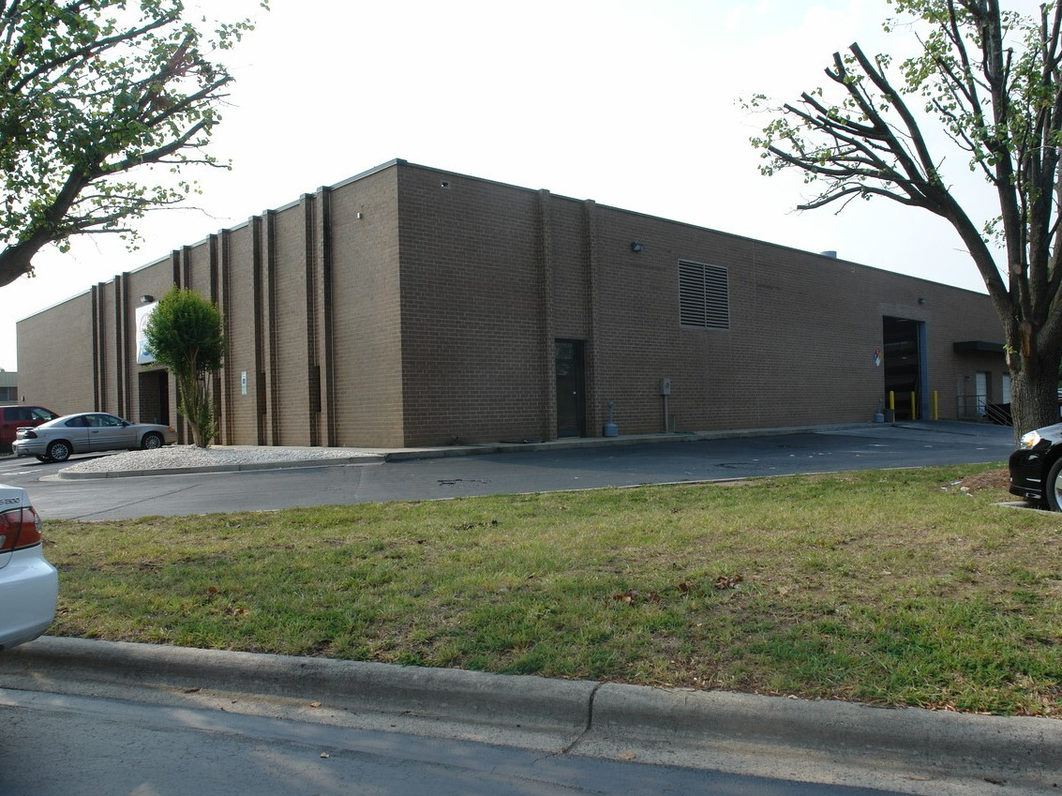

Comparable Rental 1

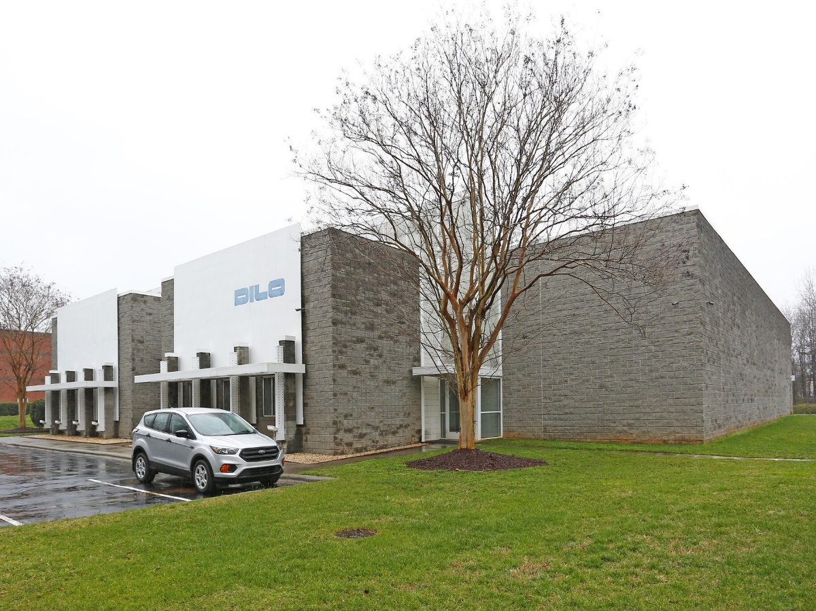

Comparable Rental 2

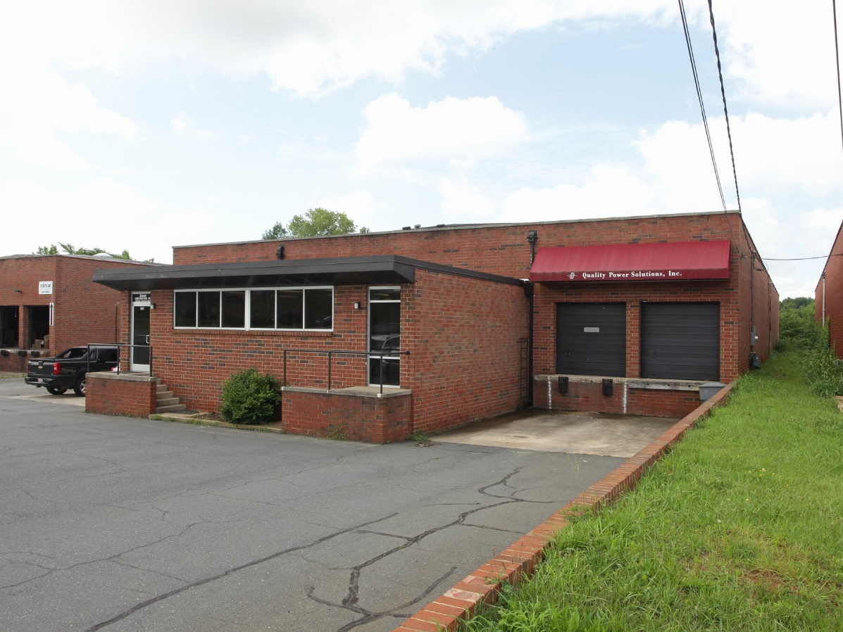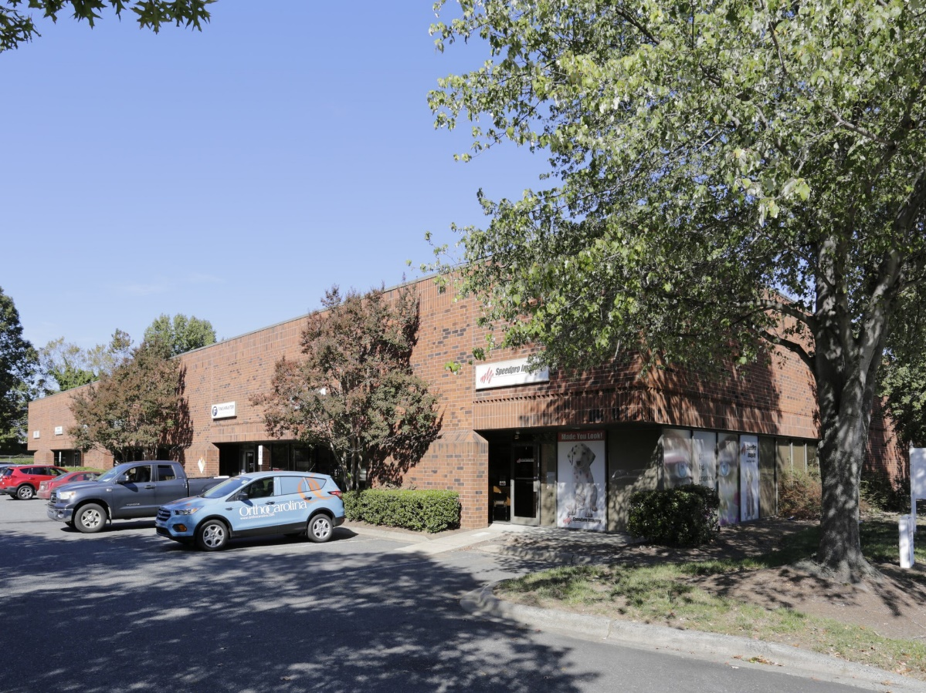

Comparable Rental 4

Comparable Rental 3

Comparable Rentals Map

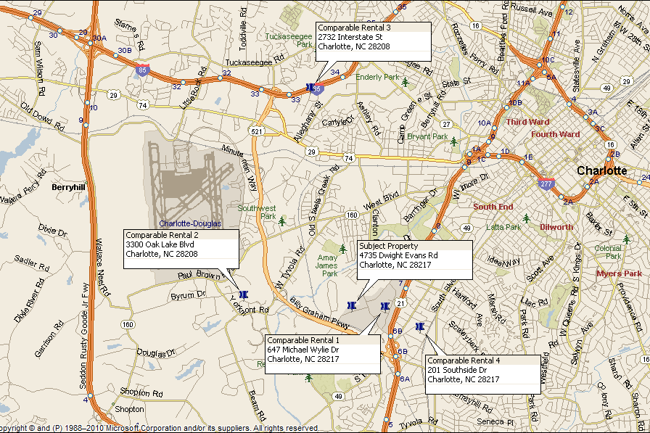

Comparable Rentals Adjustment Grid

|  |  |  |  |  |  |
| --- | --- | --- | --- | --- | --- |
|  | Subject | Rental 1 | Rental 2 | Rental 3 | Rental 4 |
| Address | 4735 Dwight Evans Rd | 647 Michael Wylie Dr | 3300 Oak Lake Blvd | 2732 Interstate St, Ste F | 201 Southside Dr |
| Charlotte, NC | Charlotte, NC | Charlotte, NC | Charlotte, NC | Charlotte, NC |
| Rentable Building Area (SF) | 16,268 | 18,090 | 16,492 | 3,628 | 13,700 |
| Lease Rate (S/SF/Yr) |  | $11.24 | $8.51 | $9.76 | $9.36 |
| Transactional Adjustments |  |  |  |  |  |
| Property Rights Conveyed |  | Typical | Typical | Typical | Typical |
| Adjustment |  | $0.00 | $0.00 | $0.00 | $0.00 |
| Adjusted Rent/SF/Yr |  | $11.24 | $8.51 | $9.76 | $9.36 |
| Lease Structure |  | NNN | NNN | NNN | NNN |
| Adjustment |  | $0.00 | $0.00 | $0.00 | $0.00 |
| Adjusted Rent/SF/Yr |  | $11.24 | $8.51 | $9.76 | $9.36 |
| Conditions of Lease |  | 10-year term | None | None | None |
| Adjustment |  | -$1.04 | $0.00 | $0.00 | $0.00 |
| Adjusted Rent/SF/Yr |  | $10.20 | $8.51 | $9.76 | $9.36 |
| Market Conditions |  | Aug-21 | Mar-21 | Jun-21 | Jul-20 |
| Adjustment |  | $0.34 | $0.43 | $0.39 | $0.72 |
| Adjusted Rent/SF/Yr |  | $10.54 | $8.94 | $10.15 | $10.08 |
| Property Adjustments |  |  |  |  |  |
| Location |  | 0.0% | 10.0% | 10.0% | 0.0% |
| Rentable Building Area (SF) | 16,268 | 1.0% | 0.0% | -10.0% | -2.0% |
| Quality | Average | -10.0% | -10.0% | -10.0% | 0.0% |
| Effective Age/Condition | 10 years | -10.0% | -5.0% | 0.0% | 0.0% |
| Access | Good | 0.0% | 0.0% | 0.0% | 0.0% |
| Finished Ratio | 7.4% | 0.0% | 0.0% | -3.0% | -2.0% |
| Parking Ratio | 0.92/1,000 SF | 0.0% | 0.0% | 0.0% | 0.0% |
| Eave Height | 18 feet | 2.0% | 1.0% | 1.0% | 1.0% |
| Loading | 0 GL/3 DH | 0.0% | 0.0% | 0.0% | 0.0% |
| Other | None | 0.0% | 0.0% | 0.0% | 0.0% |
| Net Adjustment |  | -17.0% | -4.0% | -12.0% | -3.0% |
| Adjusted Rent/SF/Yr |  | $8.75 | $8.58 | $8.93 | $9.78 |

Comparable Rentals Analysis

*Property Rights Conveyed*

Adjustments under this category are required when the rights conveyed between parties of the transaction involve restrictions, purchase options, or non-realty items. All the comparable lease transactions represent typical fixed-term leases, with no adjustments required.

*Expense Structure*

The forecasted income for the subject property was based on a triple-net lease structure. All the comparable leases were structured as triple-net leases, with no adjustments required.

*Lease Conditions*

This category is included for consideration of rent concessions, atypical tenant improvements, and other extraordinary conditions between the parties to the transaction. The effective rent for Comparable Rental 1 was based on a 10-year lease term. A downward adjustment was applied in conformance with a more typical term of five years. No other adjustments were noted under this category.

*Market Conditions*

According to CoStar Group[10], overall average asking rents for industrial properties in the Charlotte market have experienced declining vacancy and increasing rental rates over the last few several quarters. In this instance, we utilize upward adjustments based on an estimated rental rate appreciation of 1.0% per quarter.

*Location*

This category of adjustment is intended to reflect differences in the locational characteristics of the comparable properties with respect to attributes such as proximity to supporting uses and transportation routes, competitive supply and demand trends, and the general character or reputation of the market area.

In this instance, we made adjustments based on differences in rent levels of the various comparable rental submarkets. We note that differences in inventory, average building size, and average age of the comparable rental submarkets were considered in the analysis. The table on the following page presents the respective submarkets and their average asking rental rates.

|  |  |  |  |  |
| --- | --- | --- | --- | --- |
|  | *Market* | *Avg. Asking Rent* | *Implied Adjustment* | *Applied Adjustment* |
| *Subject* | *Tyvola Rd* | *$10.43* | *-* | *-* |
| *Rentals 2 & 3* | *Airport/West* | *$8.13* | *22%* | *10%* |

*Building Size*

Differences in lease rates are often attributable to the variation in size of the leased space. The subject building contains 16,268 square feet of rentable building area. The following table on the summarizes the adjustments applied to the comparable rentals.

|  |  |  |  |
| --- | --- | --- | --- |
|  | *Rentable Building Area (SF)* | *Difference (SF)* | *Applied Adjustment* |
| *Rental 1* | *18,090* | *1,822* | *1%* |
| *Rental 2* | *16,492* | *224* | *0%* |
| *Subject* | *16,268* | *-* | *-* |
| *Rental 4* | *13,700* | *2,568* | *-2%* |
| *Rental 3* | *3,628* | *12,640* | *-10%* |

*Quality*

Differences in construction, quality and appeal are considered in this category. Comparable rentals 1, 2 and 3 were considered superior in this respect and adjusted downward accordingly. All the other comparable rentals were considered sufficiently similar in terms of overall quality and quality of finishes with no adjustments considered necessary.

*Effective Age*

Adjustments under this category account for differences in the estimated effective age of the subject property relative to the comparable data set. The estimated effective ages of comparable rentals 1 and 2 are considered less than the estimated effective age of the subject and adjusted downward accordingly. Adjustments were based on inspection of interior photographs and broker comments when available.

*Access*

This category of adjustment considers traffic counts and visibility from main thoroughfares and the relative ease of ingress and egress to the site. Other considerations include, but are not limited to, corner influences, frontages, access points and immediate surrounding interchanges. All the comparable rentals were considered sufficiently similar in this respect with no adjustments warranted.

*Office Ratio*

The subject building is improved with 1,209 square feet of retail/office area which equates to a finished ratio of 7.4%. Adjustments for differences in finished ratios are based on a contributory value estimate of $15 per square foot. Comparable rentals 3 and 4 were adjusted downward accordingly.

*Parking Ratio*

Parking ratios were determined by the number of dedicated parking spaces on asphalt surfaces. All the comparable rentals were considered sufficiently similar to the subject with no adjustments necessary.

*Eave Height*

The subject building’s minimum clear height was measured to 18 feet. Upward adjustments were applied to all the comparable rentals. Adjustments were applied accordingly based on a similar methodology detailed in the *Sales Comparison Approach*.

*Loading*

The subject building contains three dock-high loading positions which equates to one loading position per 5,423 square feet. All the comparable rentals were considered sufficiently similar in this respect with no adjustments warranted.

Market Rent Conclusion

|  |  |  |  |  |  |
| --- | --- | --- | --- | --- | --- |
|  | Minimum | Maximum | Mean | Median | Std Dev |
| Unadjusted Rent Per SF | $8.51 | $11.24 | $9.72 | $9.56 | $0.99 |
| Adjusted Rent Per SF | $8.58 | $9.78 | $9.01 | $8.84 | $0.46 |

In this instance, we estimate market rent for the subject building to be $9.00 per square foot per year. For purposes of our analysis, we utilize $9.00 per square foot per year on a triple-net basis with the tenant responsible for property taxes, insurance, utilities, repairs, and interior and exterior maintenance.

Potential Gross Income

Based on the data, we calculate the potential gross income for the subject property as follows:

|  |  |  |
| --- | --- | --- |
| Building Size (SF) | Market Rent | Annual Rent |
| 16,268 | $9.00 | $146,412 |

Analysis of Expenses

*Vacancy and Collection Loss*

Vacancy and collection loss is an allowance for reductions in potential gross income attributable to vacancies, tenant turnover and non-payment of rent. According to CoStar, the vacancy rate for retail properties in the subject’s market is currently 3.2%. In this instance, we utilize a provision of 3% for vacancy and 1% for collection loss.

*Operating Expenses*

Comparable rentals indicate a typical lease structure in the market. We assume the building would be leased on a triple-net basis with the tenants paying taxes, insurance, utilities, repairs and interior and exterior maintenance, and the landlord is responsible for management, leasing, and a reserve for replacements. A discussion of these expenses follows.

*Property Management*

Property management expense for similar properties typically ranges from 3% to 5% of effective gross income. Given the property’s size and single-tenant configuration, we believe 2% is appropriate for the subject.

*Reserves for Replacement*

On a stabilized basis, a reserve fund is typically set for replacement of building components which have a shorter economic life than the building itself such as appliances, carpet, roof, and air conditioning equipment. We have estimated the subject’s reserves expense to be 2% of effective gross income in our analysis.

|  |  |  |  |  |
| --- | --- | --- | --- | --- |
| Income Pro Forma | | | | |
| Revenue |  |  |  |  |
| Base Rent |  |  |  | $146,412 |
| Other Income |  |  |  | $0 |
| Reimbursements |  |  |  | $0 |
| Potential Gross Income |  |  |  | $146,412 |
| Vacancy and Collection Loss | 4.0% |  |  | ($5,856) |
| Effective Gross Income |  |  |  | $140,556 |
| Expenses |  |  |  |  |
| Property Management | 2.0% | $2,811 |  |  |
| Reserves | 2.0% | $2,811 |  |  |
| Total Expenses |  |  |  | ($5,622) |
| Net Operating Income |  |  |  | $134,933 |

Mortgage-Equity Capitalization

The mortgage-equity capitalization is a band of investment technique which combines weighted-average rates of the debt and equity portions of a capital investment to derive an overall capitalization rate (RO). This rate is the combination of the return to debt (RM) and the return to equity (RE). Given a mortgage ratio of M, the overall capitalization rate is calculated as:

Ro = M x RM + (1 – M) x RE

The cost of debt was calculated using mortgage rates, terms, and loan-to-value assumptions from published surveys. In our opinion, a debt constant based on a 4.25% mortgage rate for 30 years with a 10-year call or balloon is considered appropriate for the subject property and is consistent with the present market.

According to RealtyRates.com Investor Survey 1st Quarter 2022, equity dividend rates for industrial properties range from 7.4% to 15.7% with an average of 12.7%. In this instance, we believe an equity capitalization rate of 12.0% is appropriate reflecting the degree of risk associated with this type of investment. Our assumptions are summarized in the following table.

|  |  |  |
| --- | --- | --- |
| Band of Investment Assumptions | | |
| Mortgage Interest Rate | 4.25% |  |
| Amortization Period | 30 | Years |
| Mortgage Ratio (Loan-to-Value) | 75% |  |
| Mortgage Constant | 0.0590 |  |
| Equity Dividend Rate | 12.0% |  |
| Holding Period | 10 | Years |

Based on a 10-year holding period and the above-defined assumptions, we calculate the overall capitalization rate by the mortgage-equity technique as follows:

|  |  |  |  |  |  |  |
| --- | --- | --- | --- | --- | --- | --- |
| Mortgage-Equity Capitalization Rate | | | | | | |
| Mortgage Requirement | 0.75 | X | 0.0590 | = |  | 0.0443 |
| Equity Requirement | 0.25 | X | 0.1200 | = |  | 0.0300 |
| Indicated Capitalization Rate | | | | |  | 0.0743 |

The indicated capitalization rate by the mortgage-equity technique is 7.43%. In our opinion, the rate is reasonable and well-supported, as the data utilized for the assumptions are extracted from the market reflecting current mortgage interest rates and investor’s expected return on equity.

Debt Service Coverage Ratio Technique

This approach is similar to the band of investment technique in that the same risk and reward factors are inherent in both formulas: leverage, loan-to-value ratios, cost of debt, and debt service coverage ratios (DSCR). Lenders typically constrain the size of a mortgage based on the ability to service the debt. Generally, the DSCR is the ratio of net operating income to debt service. Lender requirements vary based on property type and the economic environment among other factors.

Given a mortgage ratio of M, the overall capitalization rate is calculated as follows:

Ro = M x RM x DSCR

According to RealtyRates.com Investor Survey 4th Quarter 2021, debt coverage ratios for industrial properties range from 1.10 to 1.55 with an average of 1.33. Utilizing a debt coverage ratio of 1.5 times debt service yields the following:

|  |  |  |  |
| --- | --- | --- | --- |
| Mortgage Ratio | Mortgage Constant | Debt Coverage Ratio | Indicated Capitalization Rate |
| 75% | 0.0590 | 1.50 | 0.0664 |

The indicated capitalization rate by the debt service coverage ratio technique is 6.64%.

Charlotte Market Sales History

According to CoStar,[11] overall capitalization rates for industrial properties in the Tyvola Road submarket are currently 6.4% as shown in the table below.

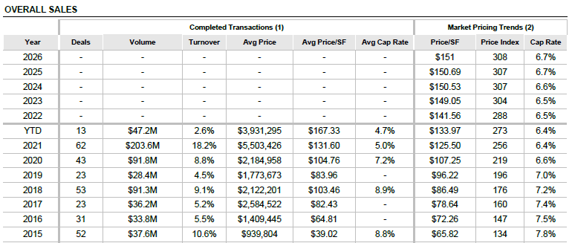

Capitalization Rate Conclusion

Our estimate of the overall capitalization rate for the subject property is presented below. The estimate is bracketed within the ranges exhibited by the comparable sales and survey data.

|  |  |  |
| --- | --- | --- |
| Capitalization Rate Conclusion | | |
|  | Range | Average |
| Realty Rates Investor Survey* | 4.3% - 12.8% | 9.00% |
| Mortgage-Equity Technique | - | 7.43% |
| Debt Coverage Ratio Technique | - | 6.64% |
| CoStar Pricing Trend -*YTD 2Q22* | - | 6.40% |
| Conclusion | | 7.00% |

*\*1Q 2022 Industrial*

Value Conclusion

Based on our analysis, we estimate the market value of the subject property by the Income Capitalization Approach as follows:

|  |  |  |
| --- | --- | --- |
| **Market Value “’As-Is”** | | |
| **Income Capitalization Approach** | | |
| **Net Operating Income** | **Capitalization Rate** | **Indicated Value** |
| $134,933 | 7.00% | $1,927,619 |
| **Rounded:** | | **$1,930,000** |

# RECONCILIATION AND FINAL VALUE CONCLUSIONS

Reconciliation is the last phase in the development of a value opinion in which two or more value indications derived from market data are resolved into a final value opinion, which may be either a final range of value or a single point estimate.[12]

Summary of Value Indications

|  |  |
| --- | --- |
| **Market Value “As Is”** | |
| **Sales Comparison Approach** | **$1,950,000** |
|  |  |
| **Income Capitalization Approach** | **$1,930,000** |

*Sales Comparison Approach*

The Sales Comparison Approach represents the primary method by which the fee simple interest in similar properties is evaluated. Properties similar to the subject are frequently sold in the local market, and there are typically sufficient data available to provide a credible opinion of market value. This approach was given primary weight in the reconciliation.

*Income Capitalization Approach*

The Income Approach is based upon investor expectations for the income stream generated by an income-producing property. Properties similar to the subject are evaluated using the direct capitalization technique. As the typical buyer profile is an owner-occupant, this approach was given secondary weight in the final analysis.

Market Value Conclusion

Based on the examination and analysis, it is our opinion that the market value of the fee simple interest in the subject real property, exclusive of furniture, fixtures, and equipment and subject to certain definitions, assumptions and limiting conditions as set forth in the accompanying report, as of July 5, 2022, was:

|  |
| --- |
| **ONE MILLION NINE HUNDRED FIFTY THOUSAND DOLLARS** |
| **$1,950,000** |

# CERTIFICATION

I certify that, to the best of my knowledge and belief:

* That the statements of fact contained in this report are true and correct.
* The reported analyses, opinions, and conclusions are limited only by the reported assumptions and limiting conditions and are my personal, impartial, and unbiased professional analyses, opinions, and conclusions.
* I have no present or prospective interest in the property that is the subject of this report and no personal interest with respect to the parties involved.
* I have not performed services regarding the property that is the subject of this report within the three-year period immediately preceding acceptance of this assignment.
* I have no bias with respect to the property that is the subject of this report or to the parties involved with this assignment.
* My engagement in this assignment was not contingent upon developing or reporting predetermined results.
* My compensation for completing this assignment is not contingent upon the development or reporting of a predetermined value or direction in value that favors the cause of the client, the amount of the value opinion, the attainment of a stipulated result, or the occurrence of a subsequent event directly related to the intended use of this appraisal.
* My analyses, opinions, and conclusions were developed, and this report has been prepared, in conformity with the Uniform Standards of Professional Appraisal Practice.

• J. Carl Talbott, III made a personal inspection of the property that is the subject of this report. No one provided significant professional appraisal assistance to the persons signing this report.

* The reported analyses, opinions, and conclusions were developed, and this report has been prepared, in conformity with the requirements of the Code of Professional Ethics and the Standards of Professional Appraisal Practice of the Appraisal Institute.
* The use of this report is subject to the requirements of the Appraisal Institute relating to review by its duly authorized representatives.
* As of the date of this report, Carl Talbott has completed the Standards and Ethics Education Requirements for Candidates of the Appraisal Institute.



J. Carl Talbott, III

Certified General Real Estate Appraiser

North Carolina Temporary License No. 10729

# ADDENDA

Assumptions and Limiting Conditions

The estimate of value contained in this appraisal report is based upon the following basic assumptions and limiting conditions:

1. This report is based in part upon information carefully selected from a variety of sources, including public records and other sources deemed reliable. While a reasonable effort has been made to verify such information, no responsibility is assumed by the appraisers for its accuracy.

2. It is assumed that the legal description and plats of the subject property obtained from public records are correct. The plot plans and sketches included in this report are intended only to assist the reader in visualizing the property and should not be construed as engineering surveys or drawings.

3. The appraisers assume no responsibility for matters legal in nature nor do the appraisers render any opinion as to the property title, which is assumed to be marketable. All existing liens, encumbrances and assessments have been disregarded, and the property has been appraised as though free and clear and under responsible ownership and competent management.

4. It is assumed that all applicable zoning and use regulations and restrictions have been complied with, unless a non-conformity has been stated, defined and considered in this report.

5. It is assumed that all required licenses, consents or other legislative or administrative authority from any local, state or national governmental or private entity or organization have been or can be obtained or renewed for any use on which the value estimate contained in this report is based.

6. It is assumed that the utilization of the land and improvements of the subject is within the boundaries or property lines described and that there is no encroachment or trespass unless noted within the report.

7. It is assumed that there is full compliance with all applicable federal, state and local environmental regulations and laws unless non-compliance is stated, defined and considered in this report.

8. No soil borings or analyses have been made of the subject. It is assumed that soil conditions are adequate to support standard construction consistent with the highest and best use as stated in this report, and that there are no surface or sub-surface conditions or contaminants present that would materially impact value.

9. No responsibility is assumed for engineering matters, neither mechanical nor structural. Good mechanical and structural condition is assumed to exist.

10. Unless otherwise stated in this report, the existence of hazardous material, which may or may not be present on the property, was not observed by the appraiser. The appraiser has no knowledge of the existence of such materials on or in the property. The appraiser, however, is not qualified to detect such substances. The presence of substances such as asbestos, urea-formaldehyde foam insulation, or other potentially hazardous materials may affect the value of the property. The value estimate is predicated on the assumption that there is no such material on or in the property that would cause a loss in value. No responsibility is assumed for any such conditions, or for any expertise or engineering knowledge required to discover them. The client is urged to retain an expert in this field, if desired.

11. No environmental impact studies were either requested or conducted in conjunction with this appraisal, and the appraiser hereby reserves the right to alter amend, revise or rescind any of the value opinions based upon any subsequent environmental impact studies, research or investigation.

12. The Americans with Disabilities Act (ADA) became effective January 26, 1992. We have not made a specific compliance survey and analysis of this property to determine whether or not it is in conformity with the various detailed requirements of the ADA. It is possible that a compliance survey of the property together with a detailed analysis of the requirements of the ADA could reveal that the property is not in compliance with one or more of the requirements of the act. If so, this fact could have a negative effect upon the value of the property. We did not consider possible noncompliance with the requirements of ADA in estimating the value of the property.

13. Disclosure of the contents of this report is governed by the By-Laws and Regulations of the Appraisal Institute and is subject to the requirements of the Appraisal Institute relating to review by its duly authorized representatives. Neither all nor any part of the contents of this report (especially any conclusions as to value, the identity of the appraisers or the firm with which the appraisers is/are connected, or any reference to the Appraisal Institute or to the MAI or SRA designations) shall be disseminated to the public through advertising, public relations, news or sales media or any other public means of communication without the prior written consent and approval of the undersigned.

14. Unforeseeable events such as national disaster, war, depression or runaway inflation are not anticipated and would require changes in the value estimated in this report.

15. This appraisal was prepared for the confidential use of the client for the purpose specified and must not be used in any other manner without the written consent of the appraisers. The report and the data herein contained, except that provided by the client, remain the exclusive property of our firm.

16. Possession of this report, or a copy thereof, does not carry with it the right of publication.

17. The appraisers will not be required to provide further consultation or testimony or to appear in court by reason of this appraisal unless previous arrangements have been made.

18. I/we assume no responsibility for the business decisions of those who become aware of this report.

19. The individual values estimated for the various components of the subject property are valid only when taken in the context of this report and are invalid if considered individually, or as components in connection with any other appraisal.

20. This report is null and void if used in any connection with a real estate syndicate or syndication, defined as a general or limited partnership, joint venture, un­incorporated association or similar organization formed for or engaged in investment or gain from an interest in real property, including but not limited to a sale, exchange, trade, development, or lease of property on behalf of others, or which is required to be registered with the United States Securities and Exchange Commission or any Federal or State Agency which regulates investments made as a public offering.

21. If this appraisal is used for mortgage loan purposes, the appraisers invite attention to the fact that: (1) the equity cash requirements of the sponsor have not been analyzed, (2) the loan ratio has not been suggested, (3) the amortization method and term have not been suggested, and (4) in the case of property to be constructed, compliance with plans and specifications is yet to be determined.

22. In the event the validity of any finding of this appraisal is questioned, the parties agree to binding arbitration. Each party shall select and pay for an independent MAI designated appraiser. The independent appraisers shall select a third MAI appraiser to be paid by both parties. The panel of appraisers shall expeditiously resolve any and all issues raised, and their findings shall be binding on all parties.

Qualifications of the Appraiser

**J. CARL TALBOTT, III**

**COMMERCIAL REAL ESTATE APPRAISER & CONSULTANT**

**Professional Affiliations:**

Appraisal Institute Candidate for Designation No. 532595

Certified General Real Estate Appraiser

Georgia Real Estate Appraisal Board No. 342441

**Education:**

University of Alabama, Master of Arts

Concentration: Economics and Finance

Mississippi State University, Bachelor of Business Administration

Concentration: Banking and Finance

**Appraisal Institute**

General Appraiser Market Analysis and Highest and Best Use 2012

Real Estate Finance, Statistics and Valuation Modeling 2012

General Appraiser Sales Comparison Approach 2012

General Appraiser Site Valuation and Cost Approach 2012

General Appraiser Income Approach / Part II 2013

Advanced Income Capitalization 2013

General Appraiser Report Writing and Case Studies 2013

7-Hour National USPAP Equivalent Course 2015

Business Practices and Ethics 2015

Quantitative Analysis 2016

Advanced Market Analysis and Highest and Best Use 2016

Advanced Concepts and Case Studies 2016

7-Hour National USPAP Equivalent Course 2020

**Experience:**

Valuation of Apartment Buildings, Automotive Dealerships, Carwash Facilities, Commercial Land, Condominium Developments, Convenience Stores, Dairy Farms, Flex Buildings, Funeral Homes, Golf Courses, Hotels/Motels, Industrial Buildings, Machinery and Equipment, Manufacturing Facilities, Mobile Home Parks, Nursing Facilities, Office Buildings, Poultry Operations, Refrigeration/Cold Storage Facilities, Religious Facilities, Residential Land, Restaurants, Retail Stores, Right-of-Way Acquisition and Property Condemnation, RV Parks, Shopping Centers, Subdivisions, Veterinary Clinics and Warehouse/Distribution Facilities.

Comparable Sales Data

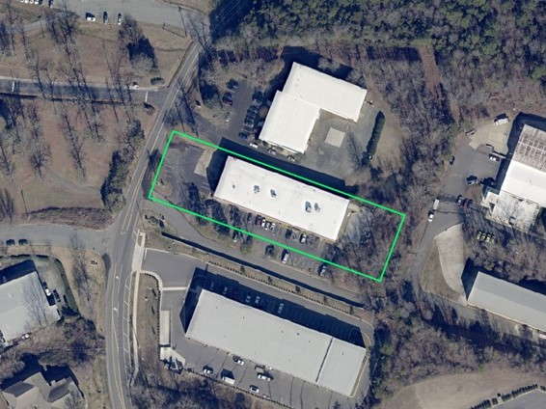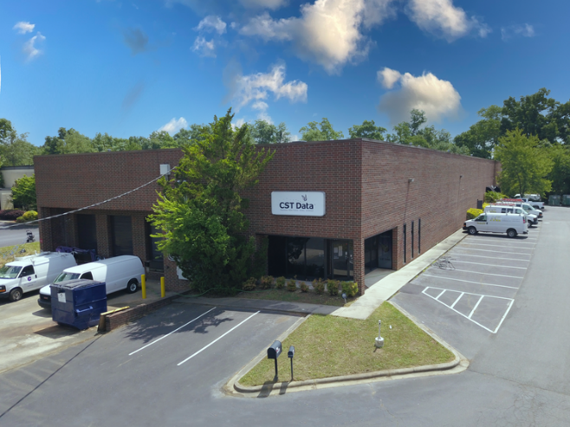

|  |  |
| --- | --- |
| Comparable Sale 1 | |
| Location Details | |
| Address | 10725 John Price Rd |
| Charlotte, NC |
| Parcel No.(s) | 201-181-27 |
| Transaction Data | |
| Date of Sale | 5/17/2022 |
| Sale Price | $2,275,000 |
| Price/SF | $115.99 |
| Grantor | MSE Center LLC |
| Grantee | Sand Fiddlers Partners, LLC |
| Property Rights | Leased Fee |
| Occupancy ATOS | 50% |
| Verification | Listing Broker |
| Physical Attributes | |
| Gross Building Area (SF) | 19,614 |
| Year Built | 1988 |
| Site Size (SF) | 60,984 |
| Coverage Ratio | 32.2% |
| Office Ratio | 22.5% |
| Quality | Average |
| Effective Age/Condition | 10 years |
| Access | Good |
| Parking Ratio | 1.48/1,000 SF |
| Building Use | Industrial |
| Eave Height | 20 feet |
| Loading | 1 GL/3 DH |
| Loading SF | 4,904 |
| Comments | |
| The sale of a freestanding, multi-tenant industrial building located on the southeast side of John Price Road just north of South Tryon Street and about two miles southwest of the Interstate 485/South Tryon Street interchange within the city limits of Charlotte. The building was constructed in 1988 and features concrete block construction, wet sprinkler system and a clear height of 20'. The two-suite building was 50 percent occupied at the time of sale with the tenant leased through August 2026. The property was on the market for about nine months with an original asking price of $2,300,000. Truist Bank financed the deal with a loan in the amount of $1,955,000. | |

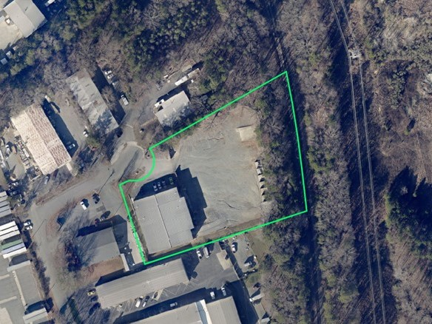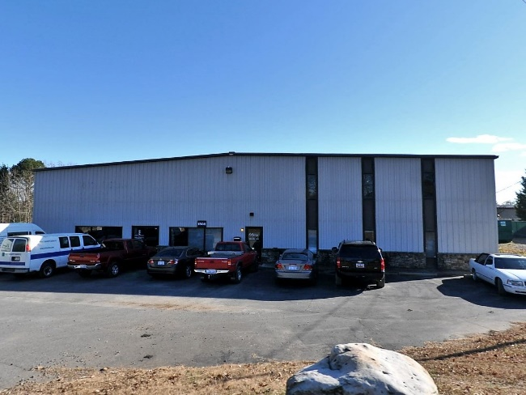

|  |  |
| --- | --- |
| Comparable Sale 2 | |
| Location Details | |
| Address | 1508 Industrial Dr |
| Matthews, NC |
| Parcel No.(s) | 193-211-07 |
| Transaction Data | |
| Date of Sale | 12/17/2021 |
| Sale Price | $1,845,000 |
| Price/SF | $143.69 |
| Grantor | Match Properties, LLC |
| Grantee | Wilkat, LLC |
| Property Rights | Fee Simple |
| Occupancy ATOS | Vacant |
| Verification | Listing Broker |
| Physical Attributes | |
| Gross Building Area (SF) | 12,840 |
| Year Built | 1986 |
| Site Size (SF) | 105,981 |
| Coverage Ratio | 12.1% |
| Office Ratio | 27.3% |
| Quality | Average |
| Effective Age/Condition | 10 years |
| Access | Good |
| Parking Ratio | 0.78/1,000 SF |
| Building Use | Industrial |
| Eave Height | 18 feet |
| Loading | 1 GL/2 DH |
| Loading SF | 4,280 |
| Comments | |
| The sale of a freestanding industrial building located approximately one mile northwest of the intersection of U.S. Highway 74 and N.C. Highway 51 within the Town of Matthews in Mecklenburg County, North Carolina. The building was constructed in 1986 and features a structural-steel spanning system with a clear height of 18'. The property was on the market for about a month with an asking price of $1,875,000. The building is currently owner-occupied by a foundation repair company dba Cantey Foundation Specialists. First Palmetto Bank financed the deal with a loan in the amount of $1,800,000. | |

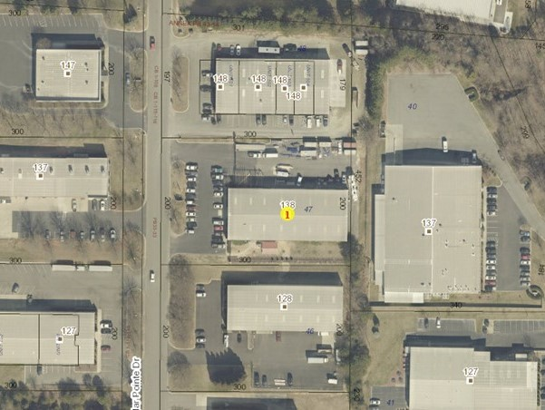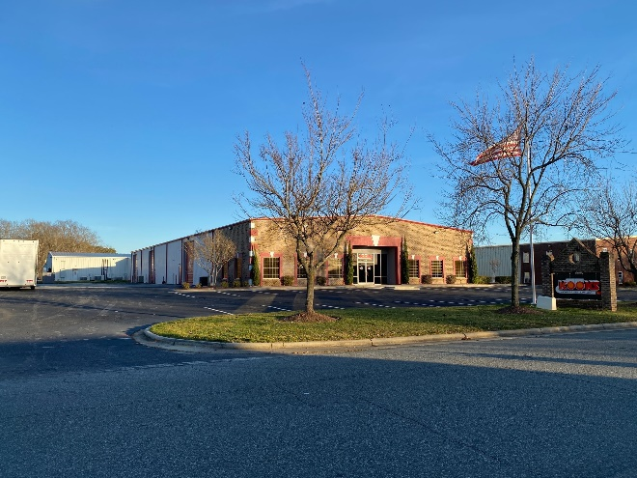

|  |  |
| --- | --- |
| Comparable Sale 3 | |
| Location Details | |
| Address | 138 Cedar Pointe Dr |
| Mooresville, NC |
| Parcel No.(s) | 4648-90-4665.000 |
| Transaction Data | |
| Date of Sale | 5/25/2020 |
| Sale Price | $1,575,000 |
| Price/SF | $103.62 |
| Grantor | D&G Realty, LLC |
| Grantee | 138 Cedar Pointe, LLC |
| Property Rights | Fee Simple |
| Occupancy ATOS | Vacant |
| Verification | Listing Broker |
| Physical Attributes | |
| Gross Building Area (SF) | 15,200 |
| Year Built | 2001 |
| Site Size (SF) | 60,113 |
| Coverage Ratio | 25.3% |
| Office Ratio | 27.6% |
| Quality | Average |
| Effective Age/Condition | 10 years |
| Access | Good |
| Parking Ratio | 2.17/1,000 SF |
| Building Use | Industrial |
| Eave Height | 18 feet |
| Loading | 3 GL/1 DH |
| Loading SF | 3,800 |
| Comments | |
| The sale of an industrial flex building located on the east side of Cedar Pointe Drive just east of Interstate 77 within the city limits of Mooresville in Iredell County, North Carolina. The property is currently owner-occupied dba Tiger Precision Products. This is believed to be an all-cash sale. | |

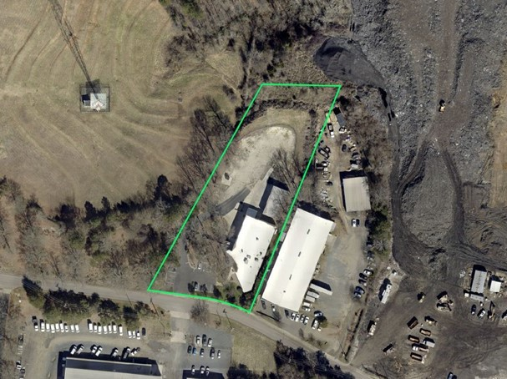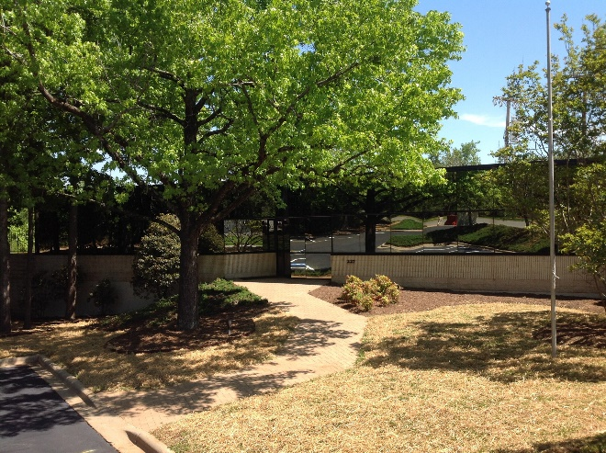

|  |  |
| --- | --- |
| Comparable Sale 4 | |
| Location Details | |
| Address | 227 Old Hebron St |
| Charlotte, NC |
| Parcel No.(s) | 205-171-24 |
| Transaction Data | |
| Date of Sale | 10/15/2020 |
| Sale Price | $1,725,000 |
| Price/SF | $134.01 |
| Grantor | OHR Properties, LLC |
| Grantee | Hop Holdings, LLC |
| Property Rights | Fee Simple |
| Occupancy ATOS | Vacant |
| Verification | Listing Broker |
| Physical Attributes | |
| Gross Building Area (SF) | 12,872 |
| Year Built | 1989 |
| Site Size (SF) | 87,120 |
| Coverage Ratio | 14.8% |
| Office Ratio | 31.0% |
| Quality | Average |
| Effective Age/Condition | 10 years |
| Access | Good |
| Parking Ratio | 1.09/1,000 SF |
| Building Use | Industrial |
| Eave Height | 21 feet |
| Loading | 1 GL/2 DH |
| Loading SF | 4,291 |
| Comments | |
| The sale of an industrial flex building located on the north side of Old Hebron Road within the city limits of Charlotte in Mecklenburg County, North Carolina. The site slopes downward from the road frontage which provides for terrace-level, climate-controlled storage below the office portion of the building. The property is also improved with a 2,294-sf ancillary industrial building with two grade-level doors. West Town Bank & Trust financed the deal with a loan in the amount of $1,705,200. | |

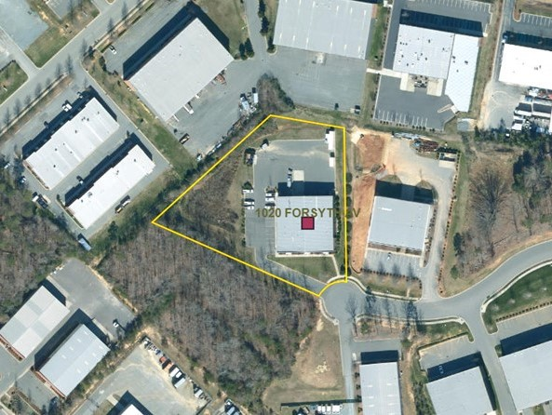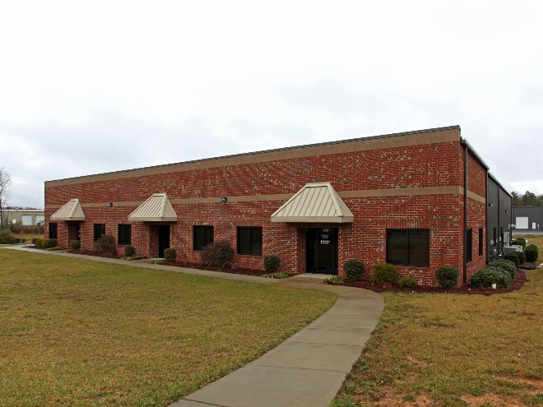

|  |  |
| --- | --- |
| Comparable Sale 5 | |
| Location Details | |
| Address | 1020 Forsyth Ave |
| Indian Trail, NC |
| Parcel No.(s) | 07-081-303 |
| Transaction Data | |
| Date of Sale | 5/26/2020 |
| Sale Price | $1,775,000 |
| Price/SF | $123.26 |
| Grantor | Pierson Enterprises, LLC |
| Grantee | Oakway Properties, LLC |
| Property Rights | Leased Fee |
| Occupancy ATOS | 67% |
| Verification | Listing Broker |
| Physical Attributes | |
| Gross Building Area (SF) | 14,400 |
| Year Built | 2008 |
| Site Size (SF) | 100,624 |
| Coverage Ratio | 14.3% |
| Office Ratio | 49.6% |
| Quality | Average |
| Effective Age/Condition | 5 years |
| Access | Good |
| Parking Ratio | 1.94/1,000 SF |
| Building Use | Industrial |
| Eave Height | 18 feet |
| Loading | 3 GL/2 DH |
| Loading SF | 2,880 |
| Comments | |
| The sale of a multi-tenant industrial flex building located in Old Hickory Business Park just northeast of East Independence Boulevard within the town limits of Indian Trail in Union County, North Carolina. At the time of sale, two of the three suites were tenant-occupied. South State Bank financed the deal with a seven-year note in the amount of $1,500,000. | |

Comparable Rental Data

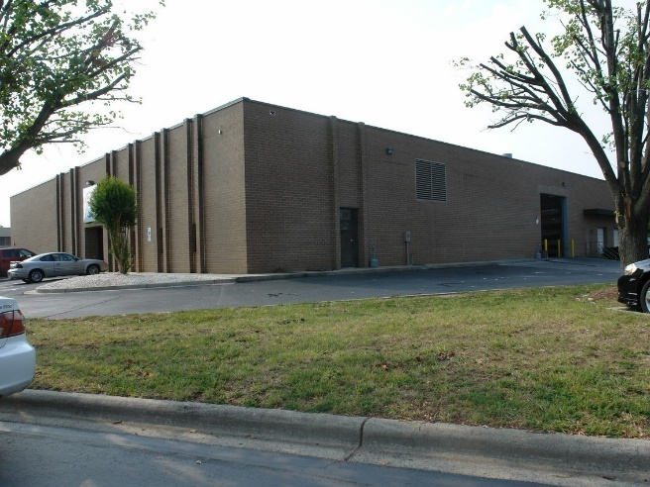

|  |  |
| --- | --- |
| Comparable Rental 1 | |
| Location Details | |
| Address | 647 Michael Wylie Dr |
| Charlotte, NC |
| Parcel No.(s) | 145-271-21 |
| Transaction Data | |
| Property Rights Conveyed | Typical |
| Tenant | Renner |
| Lease Type | Direct |
| Lease Date | Aug-21 |
| Lease Term | 120 months |
| Lease Rate (S/SF/Yr) | $11.24 |
| Expense Structure | NNN |
| Verification | Listing Broker |
| Physical Attributes | |
| Rentable Building Area (SF) | 18,090 |
| Year Built | 1982 |
| Quality | Good |
| Effective Age/Condition | 5 years |
| Finished Ratio | 10.9% |
| Access | Good |
| Parking Ratio | 0.94/1,000 SF |
| Eave Height | 15 feet |
| Loading | 2 GL/2 DH |
| Loading SF | 4,523 |
| Building Use | Industrial |
| Other | None |
| Comments | |
| This reflects the effective rent for space in an 18,090-square-foot, freestanding just north of the Interstate 77/Billy Graham Parkway interchange within the city limits of Charlotte in Mecklenburg County, North Carolina. The building is demised into 1,980 square feet of office space and 16,110 square feet of warehouse space. The ten-year, triple-net lease was executed with a starting rent of $9.95 per square foot per year having yearly escalations of 3 percent with one month free rent and a reported tenant improvement allowance of $1.00 per square foot. | |

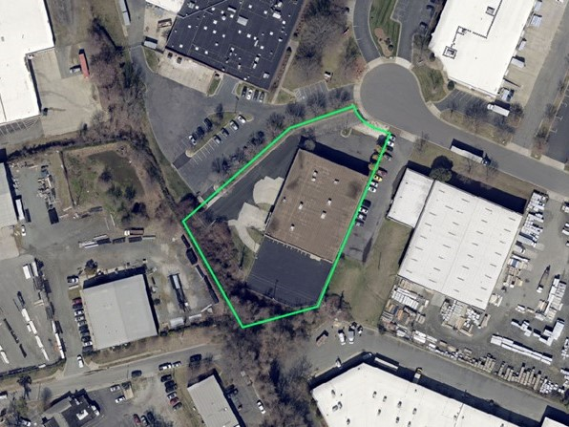

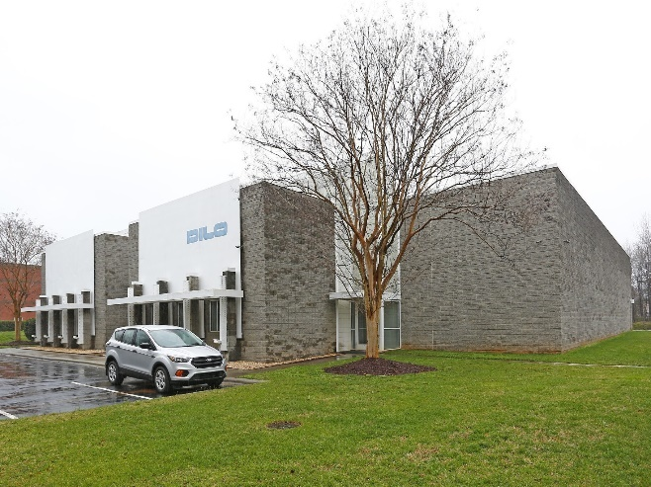

|  |  |
| --- | --- |
| Comparable Rental 2 | |
| Location Details | |
| Address | 3300 Oak Lake Blvd |
| Charlotte, NC |
| Parcel No.(s) | 143-261-05 |
| Transaction Data | |
| Property Rights Conveyed | Typical |
| Tenant | Zoe Baby Products |
| Lease Type | Direct |
| Lease Date | Mar-21 |
| Lease Term | 72 months |
| Lease Rate (S/SF/Yr) | $8.51 |
| Expense Structure | NNN |
| Verification | Listing Broker |
| Physical Attributes | |
| Rentable Building Area (SF) | 16,492 |
| Year Built | 1998 |
| Quality | Good |
| Effective Age/Condition | 7 years |
| Finished Ratio | 9.0% |
| Access | Good |
| Parking Ratio | 0.55/1,000 SF |
| Eave Height | 16 feet |
| Loading | 1 GL/1 DH |
| Loading SF | 8,246 |
| Building Use | Industrial |
| Other | None |
| Comments | |
| This reflects the effective rent for space in a 16,492-square-foot, freestanding industrial building located just east of the Billy Graham Parkway/West Tyvola Road interchange with the city limits of Charlotte in Mecklenburg County, North Carolina. The building is fully-conditioned and has approximately 1,484 square feet of office space. The triple-net lease was executed turn-key with a starting rent of $7.89 per square foot per year having 3.0 percent yearly escalations. | |

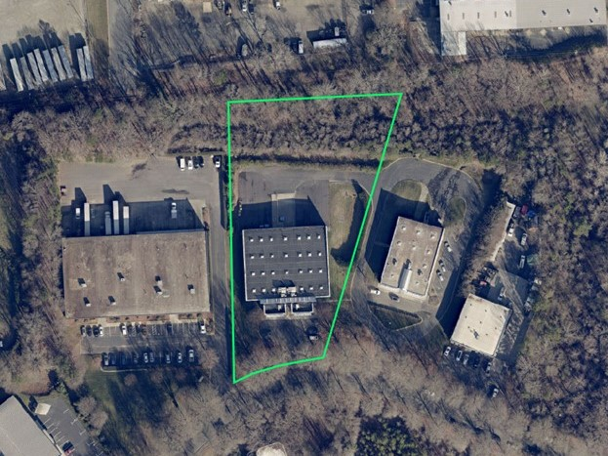

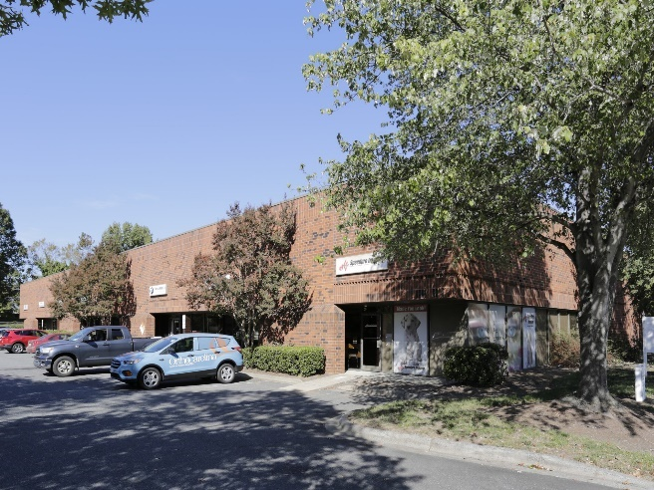

|  |  |
| --- | --- |
| Comparable Rental 3 | |
| Location Details | |
| Address | 2732 Interstate St, Ste F |
| Charlotte, NC |
| Parcel No.(s) | 061-123-12 |
| Transaction Data | |
| Property Rights Conveyed | Typical |
| Tenant | Confidential |
| Lease Type | Direct |
| Lease Date | Jun-21 |
| Lease Term | 36 months |
| Lease Rate (S/SF/Yr) | $9.76 |
| Expense Structure | NNN |
| Verification | Listing Broker |
| Physical Attributes | |
| Rentable Building Area (SF) | 3,628 |
| Year Built | 1983 |
| Quality | Good |
| Effective Age/Condition | 10 years |
| Finished Ratio | 33.1% |
| Access | Good |
| Parking Ratio | 2.11/1,000 SF |
| Eave Height | 16 feet |
| Loading | 0 GL/1 DH |
| Loading SF | 3,628 |
| Building Use | Industrial |
| Other | None |
| Comments | |
| This reflects the effective rent for space in a 26,040-square-foot, multi-tenant industrial building located in the Airport 85 Business Park just east of the Billy Graham Parkway/Interstate 85 interchange within the city limits of Charlotte in Mecklenburg County, North Carolina. The unit has approximately 1,200 square feet of office space and one dock-high door. The triple-net lease was executed turn-key with a starting rent of $9.75 per square foot per year and no escalations. The space was on the market for about 10 months with an asking rental rate of $10.00 per square foot. | |

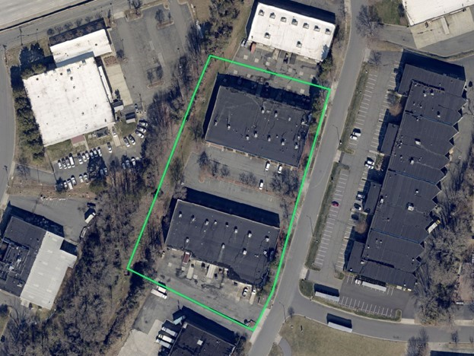

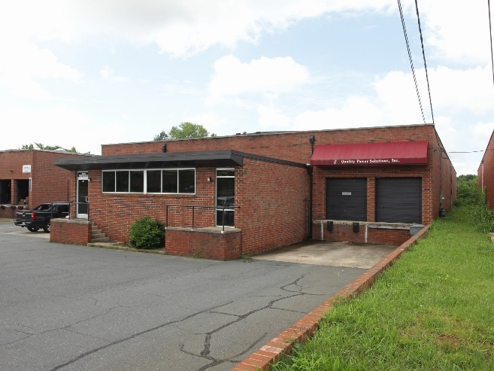

|  |  |
| --- | --- |
| Comparable Rental 4 | |
| Location Details | |
| Address | 201 Southside Dr |
| Charlotte, NC |
| Parcel No.(s) | 149-031-05 |
| Transaction Data | |
| Property Rights Conveyed | Typical |
| Tenant | J&B Construction |
| Lease Type | Direct |
| Lease Date | Jul-20 |
| Lease Term | 60 months |
| Lease Rate (S/SF/Yr) | $9.36 |
| Expense Structure | NNN |
| Verification | Listing Broker |
| Physical Attributes | |
| Rentable Building Area (SF) | 13,700 |
| Year Built | 1967 |
| Quality | Average |
| Effective Age/Condition | 10 years |
| Finished Ratio | 23.0% |
| Access | Good |
| Parking Ratio | 0.66/1,000 SF |
| Eave Height | 16 feet |
| Loading | 0 GL/2 DH |
| Loading SF | 6,850 |
| Building Use | Industrial |
| Other | None |
| Comments | |
| This reflects the effective rent for space in a 13,700-square-foot, freestanding industrial building located just northeast of the Billy Graham Parkway/Interstate 77 interchange with the city limits of Charlotte in Mecklenburg County, North Carolina. The building is demised into 3,151 square feet of office space and 10,549 square feet of warehouse space with two dock-high doors. The triple-net lease was executed turn-key with a starting rent of $9.36 per square foot per year and no escalations. | |

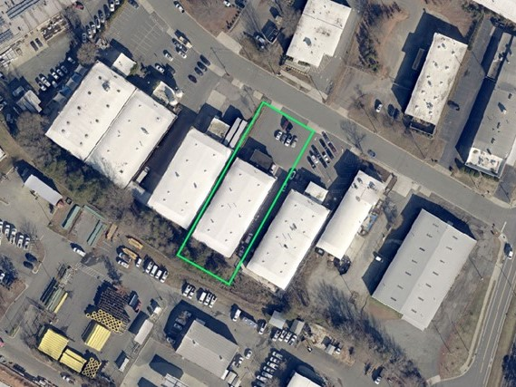

Engagement Letter

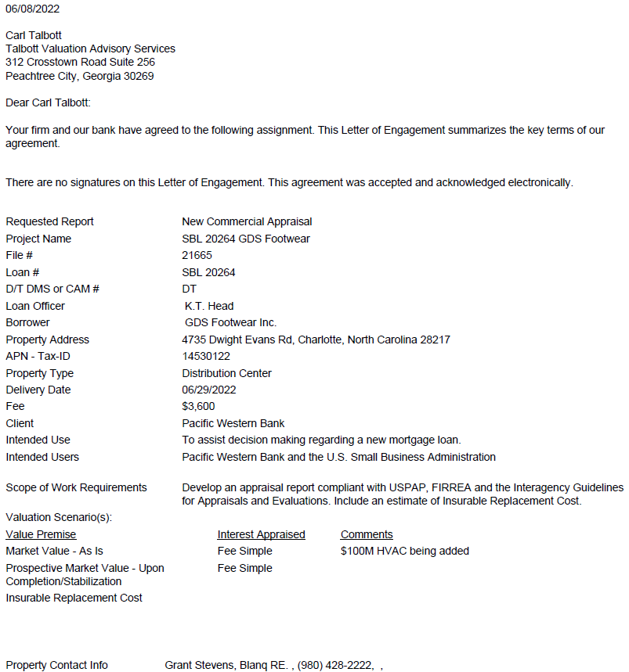

Insurable Value

We have estimated replacement costs by using the Calculator section of the *Marshall Valuation Service* cost manual, a nationally recognized publication containing construction costs for all types of improvements. This publication revises its cost factors monthly and adjusts them to reflect regional and local cost variations.

This estimate is based on "Replacement Cost New" with no depreciation and reflects only "direct" or "hard" construction costs such as construction labor and materials: repair design/engineering; permit fees; and contractor's profit, contingency, and overhead. It does not include “indirect” costs such as surveys, site development, financing, or land acquisition costs. The cost estimate’s indirect cost items typically constitute about 10% of their estimate.

|  |  |  |  |  |
| --- | --- | --- | --- | --- |
| *Replacement Cost Calculations* | | | | |
|  | | | | |
| *Occupancy* | *406 Storage Warehouse* |  |  |  |
| *Quality/Class* | *Avg/C* |  |  |  |
| *Building Size (SF)* | *16,268* |  |  |  |
|  | | | | |
|  | | | | |
|  |  | *Units* | *Unit Cost* | *Total Cost* |
| *Base Cost* |  | *16,268* | *$42.70* | *$694,644* |
| *Exterior Walls* |  | *16,268* | *$18.83* | *$306,326* |
| *Heating & Cooling* |  | *1,209* | *$7.04* | *$8,511* |
| *Total Base Cost* |  | *16,268* | *$62.05* | *$1,009,481* |
| *Insurance Exclusions* | *0.10* |  |  | *($100,948)* |
| *Indicated Replacement Cost* |  |  |  | *$908,533* |
|  |  |  |  |  |
| *Rounded:* |  |  |  | *$910,000* |

Terms and Definitions

Unless otherwise noted, the source of the following definitions is *The Dictionary of Real Estate Appraisal, Fifth Edition,* (Chicago: Appraisal Institute, 2010).

**As Is Market Value** The estimate of the market value of real property in its current physical condition, use, and zoning as of the appraisal date.

**Band of Investment** A technique in which the capitalization rates attributable to components of a capital investment are weighted and combined to derive a weighted-average rate attributable to the total investment.

**Deferred Maintenance** Needed repairs or replacement of items that should have taken place during the course of normal maintenance.

**Depreciation** A loss in property value from any cause; the difference between the cost of an improvement on the effective date of the appraisal and the market value of the improvement on the same date.

**Discounted Cash Flow (DCF) Analysis** The procedure in which a discount rate is applied to a set of projected income streams and a reversion. The analyst specifies the quantity, variability, timing, and duration of the income streams and the quantity and timing of the reversion, and discounts each to its present value at a specified yield rate.

**Effective Age** The age of property that is based on the amount of observed deterioration and obsolescence it has sustained, which may be different from its chronological age.

**Effective Date of Appraisal** The date on which the analyses, opinions, and advice in an appraisal, review, or consulting service apply.

**Entrepreneurial Profit** 1) A market-derived figure that represents the amount an entrepreneur receives for his or her contribution to a project and risk; the difference between the total cost of a property (cost of development) and its market value (property value after completion), which represents the entrepreneur’s compensation for the risk and expertise associated with development. An entrepreneur is motivated by the prospect of future value enhancement (i.e., the entrepreneurial incentive). An entrepreneur who successfully creates value through new development, expansion, renovation, or an innovative change of use is rewarded by entrepreneurial profit. Entrepreneurs may also fail and suffer losses. 2) In economics, the actual return on successful management practices, often identified with coordination, the fourth factor of production following land, labor, and capital; also called entrepreneurial return or entrepreneurial reward.

**Exposure Time** The estimated length of time the property interest being appraised would have been offered on the market prior to the hypothetical consummation of a sale at market value on the effective date of the appraiser; a retrospective estimate based on an analysis of past events assuming a competitive and open market.

**Extraordinary Assumption** An assumption, directly related to a specific assignment, which, if found to be false, could alter the appraiser’s opinions or conclusions. Extraordinary assumptions presume as fact otherwise uncertain information about physical, legal, or economic characteristics of the subject property; or about conditions external to the property such as market conditions or trends; or about the integrity of data used in an analysis.

**Fee Simple Estate** Absolute ownership unencumbered by any other interest or estate, subject only to the limitations imposed by the governmental powers of taxation, eminent domain, police power, and escheat.

**Floor Area Ratio (FAR)** The relationship between the above-ground floor area of a building, as described by the building code, and the area of the plot on which it stands; in planning and zoning, often expressed as a decimal, e.g., a ratio of 2.0 indicates that the permissible floor area of a building is twice the total land area.

**Gross Building Area** Total floor area of a building, excluding unenclosed areas, measured from the exterior of the walls of the above-grade area. This includes mezzanines and basements if and when typically included in the region.

**Highest and Best Use** The reasonably probable and legal use of vacant land or an improved property that is physically possible, appropriately supported, financially feasible, and that results in the highest value. The four criteria the highest and best use must meet are legal permissibility, physical possibility, financial feasibility, and maximum productivity. Alternatively, the probable use of land or improved property – specific with respect to the user and timing of the use – that is adequately supported and results in the highest present value.

**Highest and Best Use of Land or a Site as Though Vacant** Among all reasonable, alternative uses, the use that yields the highest present land value, after payments are made for labor, capital, and coordination. The use of a property based on the assumption that the parcel of land is vacant or can be made vacant by demolishing any improvements.

**Highest and Best Use of Property as Improved** The use that should be made of a property as it exists. An existing improvement should be renovated or retained as is so long as it continues to contribute to the total market value of the property, or until the return from a new improvement would more than offset the cost of demolishing the existing building and constructing a new one.

**Hypothetical Condition** That which is contrary to what exists but is supposed for the purpose of analysis. Hypothetical conditions assume conditions contrary to known facts about physical, legal, or economic characteristics of the subject property; or about conditions external to the property, such as market conditions or trends; or about the integrity of data used in an analysis.

**Lease** A contract in which rights to use and occupy land or structures are transferred by the owner to another for a specified period of time in return for a specified rent.

**Leased Fee Interest** A freehold (ownership interest) where the possessory interest has been granted to another party by creation of a contractual landlord-tenant relationship (i.e., a lease).

**Leasehold Interest** The tenant’s possessory interest created by a lease.

**Liquidation Value** The most probable price that a specified interest in real property should bring under the following conditions:

* Consummation of a sale within a short time period.
* The property is subjected to market conditions prevailing as of the date of valuation.
* Both the buyer and seller are acting prudently and knowledgeably.
* The seller is under extreme compulsion to sell.
* The buyer is typically motivated.
* Both parties are acting in what they consider to be their best interests.
* A normal marketing effort is not possible due to the brief exposure time.
* Payment will be made in cash in U.S. dollars, or in terms of financial arrangements comparable thereto.
* The price represents the normal consideration for the property sold, unaffected by special or creative financing or sales concessions granted by anyone associated with the sale.

This definition can also be modified to provide for valuation with specified financing terms.

**Market Area** The area associated with a subject property that contains its direct competition.

**Marketing Time** An opinion of the amount of time it might take to sell a real or personal property interest at the concluded market value level during the period immediately after the effective date of the appraisal. Marketing time differs from exposure time, which is always presumed to precede the effective date of an appraisal.

**Market Rent** The most probably rent that a property should bring is a competitive and open market reflecting all conditions and restrictions of the lease agreement, including permitted uses, use restrictions, expense obligations, term, concessions, renewal and purchase options, and tenant improvements.

**Market Value** The most probable price which a property should bring in a competitive and open market under all conditions requisite to a fair sale, the buyer and seller each acting prudently and knowledgeably, and assuming the price is not affected by undue stimulus. Implicit in this definition is the consummation of a sale as of a specified date and the passing of title from seller to buyer under conditions whereby:

* buyer and seller are typically motivated;
* both parties are well informed or well advised, and acting in what they consider their own best interests;
* a reasonable time is allowed for exposure in the open market;
* payment is made in terms of cash in U.S. dollars or in terms of financial arrangements comparable thereto; and
* the price represents the normal consideration for the property sold unaffected by special or creative financing or sales concessions granted by anyone associated with the sale.

*(Source: Code of Federal Regulations, Title 12, Chapter I, Part 34.42[g]; also Interagency Appraisal and Evaluation Guidelines, Federal Register, 75 FR 77449, December 10, 2010, page 77472)*

**Net Operating Income** The actual or anticipated net income that remains after all operating expenses are deducted from effective gross income but before mortgage debt service and book depreciation are deducted.

**Obsolescence** One cause of depreciation; an impairment of desirability and usefulness caused by new inventions, changes in design, improved processes for production, or external factors that make a property less desirable and valuable for a continued use; may be either functional or external.

**Parking Ratio** A ratio of parking area or parking spaces to an economic or physical unit of comparison. Minimum required parking ratios of various land uses are often stated in zoning ordinances.

**Prospective Opinion of Value** A value opinion effective as of a specified future date. The term does not define a type of value. Instead, it identifies a value opinion as being effective at some specific future date. An opinion of value as of a prospective date is frequently sought in connection with projects that are proposed, under construction, or under conversion to a new use, or those that have not yet achieved sellout or a stabilized level of long-term occupancy.

**Reconciliation** The last phase in the development of a value opinion in which two or more value indications derived from market data are resolved into a final value opinion, which may be either a final range of value or a single point estimate.

**Replacement Cost** The estimated cost to construct, at current prices as of the effective appraisal date, a substitute for the building being appraised, using modern materials and current standards, design, and layout.

**Reproduction Cost** The estimated cost to construct, at current prices as of the effective date of the appraisal, an exact duplicate or replica of the building being appraised, using the same materials, construction standards, design, layout, and quality of workmanship and embodying all the deficiencies, superadequacies, and obsolescence of the subject building.

**Scope of Work** The type and extent of research and analyses in an assignment.

**Stabilized Income** Income at that point in time when abnormalities in supply and demand or any additional transitory conditions cease to exist and the existing conditions are those expected to continue over the economic life of the property; projected income that is subject to change, but has been adjusted to reflect an equivalent, stable annual income.

**Vacancy and Collection Loss** A deduction from potential gross income made to reflect income reductions due to vacancies, tenant turnover, and non-payment of rent; also called vacancy and credit loss or vacancy and contingency loss. Often vacancy and collection loss is expressed as a percentage of potential gross income and should reflect the competitive market. Its treatment can differ according to the interest being appraised, property type, capitalization method, and whether the property is at stabilized occupancy.

1. *Federal Register*, Vol. 55, 165, Friday, August 24, 1990, Rules and Regulations, 12 CFR Part 34.42(F)
2. Marshall & Swift/Boeckh, *Marshall Valuation Service*, (Los Angeles: Marshall & Swift/Boeckh, 2010), Sec. 3, Pg. 2.
3. The Beige Book, June 1, 2022
4. North Carolina Snapshot, Federal Reserve Bank of Richmond, June 2022
5. CoStar Group, Charlotte, NC Economy, 2Q 2022
6. CoStar Charlotte Industrial Market Report, 2Q 2022
7. CoStar Tyvola Road Industrial Submarket Report, 2Q 2022
8. Appraisal Institute, *The Dictionary of Real Estate Appraisal, Fifth Ed*., (Chicago: Appraisal Institute, 2002)
9. Charlotte Industrial Report, 2Q 2022
10. Charlotte Industrial Market, 2Q 2022
11. Tyvola Road Industrial Submarket, 2Q 2022
12. Appraisal Institute, *The Dictionary of Real Estate Appraisal, Fifth Ed*., (Chicago: Appraisal Institute, 2010)